INTELLIGENT LOAN APPROVAL AND CREDIT LIMIT
RECOMMENDATION SYSTEM
A PROJECT REPORT
Submitted by
SHRI VISHNU T 24AD0281 AIDS-B
SUGANTHAN J 24AD0295 AIDS-C
in partial fulfillment for the award of the degree of
BACHELOR OF TECHNOLOGY
in
ARTIFICIAL INTELLIGENCE AND DATA SCIENCE

DEPARTMENT OF ARTIFICIAL INTELLIGENCE AND DATA SCIENCE
CHENNAI INSTITUTE OF TECHNOLOGY (AUTONOMOUS)
KUNDRATHUR, CHENNAI - 600 069
OCTOBER-2026


Vision of the Institute:
To be an eminent centre for Academia, Industry and Research by imparting knowledge, relevant practices and fostering innovation to address the challenges of the society.
Mission of the Institute:
IM1. To create a good learning environment through innovative curriculum and pedagogical methods.
IM2. To provide continuously updated infrastructure for academic, research and entrepreneurship activities.
IM3. To collaborate with industries for knowledge sharing and catering to their dynamic needs.
IM4. To facilitate the students in developing their technical and soft skills to address the real-world problems and nurture leadership qualities.
IM5. To nurture incubation centres, expand entrepreneurship and instil moral, social and ethical values.

Vision of the Department:
To Achieve excellent standards of quality education by keeping pace with rapidly changing technologies and to create computer professionals of global standards with capabilities of accepting new challenges in Information Technology.
Mission of the Department:
DM1. To enhance the knowledge of the students by updating curriculum and syllabi according to the changing needs of Industry.
DM2. To impart dynamic curriculum through innovative pedagogical methods.
DM3. To provide modern computing infrastructure facilities to promote research activities.
DM4. To instill critical thinking and creativity among students to develop innovative business software.

CHENNAI INSTITUTE OF TECHNOLOGY (AUTONOMOUS)
(Affiliated to Anna University, Chennai)
KUNDRATHUR, CHENNAI - 600 069
BONAFIDE CERTIFICATE
Certified that this project report titled "INTELLIGENT LOAN APPROVAL AND CREDIT LIMIT RECOMMENDATION SYSTEM" is the bonafide work of "SHRI VISHNU T (24AD0281)" and "SUGANTHAN J (24AD0295)" who carried out the project work under my supervision.
SIGNATURE SIGNATURE
HEAD OF THE DEPARTMENT PROJECT SUPERVISOR
Department of AI & DS [SUPERVISOR NAME - TO BE VERIFIED]
Chennai Institute of Technology Department of AI & DS
Kundrathur, Chennai - 600 069 Chennai Institute of Technology
Submitted for the project viva-voce examination held on ___________________ at Chennai Institute of Technology, Kundrathur, Chennai - 600 069.
INTERNAL EXAMINER EXTERNAL EXAMINER

ACKNOWLEDGEMENT
We express our gratitude to our Chairman Shri. P. SRIRAM and all trust members of Chennai Institute of Technology for providing the facility and opportunity to do this project as a part of our undergraduate course.
We are grateful to our Principal Dr. A. RAMESH M.E, Ph.D, for providing us the facility and encouragement during the course of our work.
We would like to extend our thanks to our Dean, Dr. V. SRINIVASA RAO M.Tech, PhD, for providing their valuable suggestions throughout this project.
We sincerely thank our Head of the Department, Department of Artificial Intelligence & Data Science, for having provided us with valuable guidance, resources and timely suggestions throughout our work.
We sincerely thank our Project Supervisor, [SUPERVISOR NAME - TO BE VERIFIED], Department of Artificial Intelligence & Data Science, for having provided us with valuable guidance, resources and timely suggestions throughout our work.
We would like to extend our thanks to our Project Coordinator, [COORDINATOR NAME - TO BE VERIFIED], Department of Artificial Intelligence & Data Science, for valuable suggestions throughout this project.
We wish to extend our sincere thanks to all the Faculty Members of the Department of Artificial Intelligence & Data Science, for their valuable suggestions and their kind cooperation for the successful completion of our project.
We wish to acknowledge the help received from the Lab Instructors of the Department of Artificial Intelligence & Data Science, and others for providing valuable suggestions and for the successful completion of the project.

TABLE OF CONTENTS
CHAPTER NO. | TITLE | PAGE NO.
 | ABSTRACT | i
 | LIST OF FIGURES | ii
 | LIST OF TABLES | iii
 | SYMBOLS & ABBREVIATIONS | iv
1. | INTRODUCTION | 1
1.1 | BACKGROUND | 1
1.1.1 | Global Financial Ecosystem and Credit Modernization | 1
1.1.2 | Indian Retail Credit Dynamics and Digital Lending Evolution | 1
1.2 | PROBLEM STATEMENT AND FORMULATION | 2
1.2.1 | Operational Inefficiencies in Traditional Underwriting | 2
1.2.2 | Dual-Objective Formulation: Approval vs. Credit Limit | 2
1.3 | CHALLENGES IN CONTEMPORARY RETAIL LENDING | 3
1.3.1 | Data Leakage and Extreme Class Imbalance | 3
1.3.2 | Model Explainability and Regulatory Compliance | 4
1.3.3 | Cold-Start and Diverse Applicant Profiles | 4
1.4 | PROJECT OBJECTIVES | 4
1.4.1 | Primary Engineering Objectives | 4
1.4.2 | Specific Machine Learning and MLOps Objectives | 5
1.5 | REGULATORY LANDSCAPE AND COMPLIANCE REQUIREMENTS | 5
1.5.1 | Reserve Bank of India (RBI) Digital Lending Guidelines | 5
1.5.2 | Fair Lending Principles and Equal Credit Opportunity | 6
1.6 | ETHICAL AI, FAIRNESS AND BIAS MITIGATION | 6
1.6.1 | Demographic Disparity and Protected Attributes | 6
1.6.2 | Ethical Guardrails in Automated Underwriting | 6
1.7 | SIGNIFICANCE AND STAKEHOLDER IMPACT | 7
1.8 | PROJECT SCOPE AND OPERATIONAL BOUNDARIES | 8
1.9 | LIMITATIONS OF CONVENTIONAL HEURISTIC SYSTEMS | 8
1.10 | ARCHITECTURAL OVERVIEW OF THE PROPOSED SYSTEM | 8
2. | LITERATURE REVIEW | 9
2.1 | EVOLUTION OF CREDIT RISK SCORING MODELS | 9
2.1.1 | Statistical and Linear Scorecards (Altman Z, Logistic Regression) | 9
2.1.2 | Non-Parametric Machine Learning (SVM, Neural Networks) | 9
2.2 | ADVANCED ENSEMBLE AND GRADIENT BOOSTING ALGORITHMS | 10
2.2.1 | Random Forests and Bagging Paradigms | 10
2.2.2 | Extreme Gradient Boosting (XGBoost) Architecture | 10
2.3 | CONTINUOUS CREDIT LIMIT DETERMINATION IN LITERATURE | 10
2.3.1 | Discretionary Matrix Systems vs. Regression Modeling | 10
2.3.2 | Currency Pegging and Cross-Border Credit Adaptation | 11
2.4 | MACHINE LEARNING OPERATIONS (MLOPS) PRINCIPLES | 11
2.4.1 | Hidden Technical Debt in Machine Learning Systems | 11
2.4.2 | Reproducibility, Data Lineage and Versioning (DVC, MLflow) | 11
2.4.3 | Containerization and Telemetry in Real-Time Serving | 12
2.5 | EXPLAINABLE ARTIFICIAL INTELLIGENCE (XAI) IN LENDING | 12
2.5.1 | Feature Attribution with Shapley Additive Explanations | 12
2.5.2 | Interpretability Requirements in Financial Regulation | 12
2.6 | COMPARATIVE ANALYSIS OF EXISTING BENCHMARK STUDIES | 13
2.7 | IDENTIFIED KNOWLEDGE GAPS | 13
2.8 | VALUE ADDITIONS AND NOVELTY OF THE PROPOSED SYSTEM | 14
3. | METHODOLOGY | 15
3.1 | SYSTEM OVERVIEW AND DESIGN PHILOSOPHY | 15
3.2 | DUAL-TASK MATHEMATICAL FORMULATION | 15
3.2.1 | Loan Approval Binary Classification Formulation | 15
3.2.2 | Credit Limit Regression Formulation and Loss Functions | 15
3.3 | CORE TECHNOLOGY STACK AND ENGINEERING TOOLCHAIN | 16
3.3.1 | Python Runtime and Scientific Computing Stack | 16
3.3.2 | Machine Learning Frameworks (Scikit-Learn, XGBoost) | 16
3.3.3 | MLOps Lifecycle Management (DVC, MLflow) | 16
3.3.4 | Microservice Serving and Telemetry (FastAPI, Docker, Prometheus) | 16
3.4 | MULTI-LAYERED SYSTEM ARCHITECTURE | 17
3.4.1 | Data Sources and Ingestion Layer | 17
3.4.2 | Preprocessing and Leakage-Proof Transformation Layer | 17
3.4.3 | Machine Learning Engine Layer | 20
3.4.4 | Model Registry and Governance Layer | 18
3.4.5 | High-Throughput API Serving Layer | 19
3.4.6 | Interactive Presentation and Studio Layer | 19
3.4.7 | Continuous Observability and Metrics Layer | 20
3.5 | DATA COLLECTION AND DATASET ATTRIBUTES | 20
3.5.1 | Retail Loan Bureau Dataset Schema and Distribution | 20
3.5.2 | UCI Default of Credit Card Clients Dataset Schema | 20
3.6 | DATA PREPROCESSING AND LEAKAGE PREVENTION | 21
3.6.1 | Data Validation and Cleansing Protocols | 21
3.6.2 | Strict Split-Before-Transform Architecture | 21
3.7 | FEATURE ENGINEERING AND TRANSFORMATION PIPELINES | 22
3.7.1 | Domain Financial Ratio Construction (LTI, DTI, Payment Ratios) | 22
3.7.2 | Categorical Encoding and Numerical Standardization | 22
3.8 | MACHINE LEARNING MODEL DEVELOPMENT | 23
3.8.1 | XGBoost Classification Architecture and Regularization | 23
3.8.2 | XGBoost Regression Architecture and Optimization | 23
3.8.3 | Baseline Comparative Algorithms (LR, RF, Linear Regression) | 23
3.9 | STRATIFIED TRAINING AND VALIDATION PROTOCOLS | 23
3.10 | SYSTEM INTEGRATION WORKFLOW | 24
4. | IMPLEMENTATION AND DEVELOPMENT PROCESS | 25
4.1 | ENVIRONMENT SETUP AND REPOSITORY ARCHITECTURE | 25
4.2 | MODULAR SOFTWARE IMPLEMENTATION (src/) | 25
4.2.1 | Data Ingestion and Splitting Engine (src/data/) | 25
4.2.2 | Feature Transformation Pipeline Engine (src/features/) | 25
4.2.3 | Model Training and Serialization Engine (src/models/) | 26
4.2.4 | Evaluation and Performance Reporting Engine (src/evaluation/) | 26
4.3 | HIGH-PERFORMANCE FASTAPI SERVING LAYER (api/) | 27
4.3.1 | Strict Pydantic Input/Output Contract Validation | 27
4.3.2 | Asynchronous Prediction Boundaries and Error Handling | 27
4.4 | INTERACTIVE FINANCIAL STUDIO FRONTEND (frontend/) | 28
4.4.1 | Client Architecture and Visual Design System | 28
4.4.2 | Adaptive Financial Profile Workflow (7 Applicant Profiles) | 28
4.4.3 | Real-Time Financial Metric Derivation Engine | 29
4.4.4 | Post-Decision Credit Recommendation Engine & Rules | 29
4.5 | MLOPS PIPELINE INTEGRATION AND OPERATIONALIZATION | 29
4.5.1 | DVC Pipeline and Data Hash Versioning | 29
4.5.2 | MLflow SQLite Experiment Tracking and Candidate Aliasing | 29
4.5.3 | Docker Multi-Stage Containerization | 29
4.5.4 | Prometheus Real-Time Scraping and Observability | 30
4.6 | VISUAL REPRESENTATION AND APPLICATION USER JOURNEY | 30
4.6.1 | Landing Page Experience and Visual Entry Point | 30
4.6.2 | Applicant Persona Selection and Dynamic Customization | 31
4.6.3 | Financial Profile Form & Real-Time Ratio Feedback | 32
4.6.4 | Real-Time Loan Approval Decision and Risk Explanations | 32
4.6.5 | Credit Limit Recommendation Modal and Capacity Analysis | 33
4.6.6 | Interactive Swagger API Documentation and Developer Console | 34
4.7 | ENGINEERING CHALLENGES AND TECHNICAL MITIGATIONS | 35
5. | TESTING, VALIDATION AND QUALITY ASSURANCE | 36
5.1 | MULTI-TIER VERIFICATION STRATEGY | 36
5.2 | TEST ENVIRONMENT AND REPRODUCIBILITY MATRIX | 36
5.3 | AUTOMATED UNIT TESTING | 36
5.3.1 | Data Validation and Cleansing Unit Tests | 36
5.3.2 | Leakage-Safe Feature Transformation Tests | 36
5.3.3 | Model Pipeline Serialization and Invariance Tests | 36
5.4 | INTEGRATION AND API PIPELINE TESTING | 37
5.4.1 | Loan Approval Prediction Endpoint Tests | 37
5.4.2 | Credit Limit Recommendation Endpoint Tests | 37
5.4.3 | Service Health and Telemetry Endpoint Tests | 37
5.5 | FRONTEND CONTRACT VERIFICATION AND JAVASCRIPT TESTING | 37
5.6 | USABILITY, ACCESSIBILITY AND RESPONSIVE UI TESTING | 37
5.7 | PERFORMANCE, LATENCY AND CONCURRENCY BENCHMARKING | 38
5.8 | SECURITY, INPUT SANITIZATION AND PAYLOAD PURITY | 38
5.9 | CROSS-VALIDATION STABILITY ANALYSIS | 39
5.10 | AUTOMATED TEST SUITE EXECUTION MATRIX (97 TESTS) | 39
5.11 | DEFECT IDENTIFICATION AND RECTIFICATION LOG | 40
5.12 | REQUIREMENT-TO-OUTCOME TRACEABILITY MATRIX | 40
5.13 | QUANTITATIVE IMPACT ANALYSIS OF THE PROPOSED SYSTEM | 41
6. | RESULTS, IN-DEPTH ANALYSIS AND DISCUSSIONS | 42
6.1 | EXPERIMENTAL SETUP AND EVALUATION PROTOCOL | 42
6.2 | LOAN APPROVAL CLASSIFICATION EMPIRICAL RESULTS | 42
6.2.1 | Holdout Performance Metrics (Accuracy, Precision, Recall, ROC-AUC) | 42
6.2.2 | Comparative Algorithm Evaluation (LR, RF, XGBoost) | 42
6.2.3 | Confusion Matrix and Risk-Adjusted Decision Thresholds | 43
6.2.4 | Holdout ROC-AUC Curve and Generalization Analysis | 43
6.3 | CREDIT LIMIT RECOMMENDATION EMPIRICAL RESULTS | 44
6.3.1 | Holdout Error Metrics (MAE, RMSE, R²) | 44
6.3.2 | Comparative Regressor Evaluation (Linear Regression, RF, XGBoost) | 44
6.3.3 | Residual Error Diagnostics and Distribution Analysis | 45
6.3.4 | Actual vs. Predicted Credit Limit Dispersion | 45
6.4 | FEATURE IMPORTANCE AND MODEL INTERPRETABILITY | 45
6.4.1 | Global Feature Attributions for Loan Approval | 45
6.4.2 | Predictive Driver Analysis for Credit Limit Determination | 46
6.5 | SUBGROUP FAIRNESS AND DISPARATE IMPACT ASSESSMENT | 46
6.5.1 | Performance Stability Across Demographic and Cohort Segments | 46
6.5.2 | Fairness Metrics and Regulatory Parity Compliance | 47
6.6 | OPERATIONAL TELEMETRY AND LATENCY BENCHMARKING | 47
6.7 | COMPARATIVE ARCHITECTURAL ANALYSIS WITH COMMERCIAL SYSTEMS | 47
6.8 | PRACTICAL FINANCIAL AND INSTITUTIONAL IMPLICATIONS | 48
7. | CONCLUSION AND FUTURE DIRECTIONS | 49
7.1 | COMPREHENSIVE SUMMARY OF COMPLETED WORK | 49
7.2 | KEY TECHNOLOGICAL CONTRIBUTIONS AND MILESTONES | 49
7.3 | REALIZATION OF PROJECT OBJECTIVES | 49
7.4 | KNOWN TECHNICAL CONSTRAINTS AND SCOPE BOUNDARIES | 50
7.5 | STRATEGIC ROADMAP AND FUTURE INNOVATIONS | 50
 | REFERENCES | 51
 | APPENDIX A: PRODUCTION LOAN PIPELINE CODE | 53
 | APPENDIX B: PRODUCTION CREDIT PIPELINE CODE | 54
 | APPENDIX C: PRODUCTION FASTAPI MICROSERVICE | 55
 | PO & PSO ATTAINMENT | 56
 | RESEARCH PAPER | 57

ABSTRACT
In the contemporary retail lending ecosystem, traditional manual underwriting workflows are characterized by operational latency, human subjectivity, vulnerability to data leakage, and an inability to model complex, nonlinear financial interactions. Concurrently, lenders face severe challenges in accurately recommending risk-adjusted credit limits that balance borrower credit capacity against default risk. This project designs, develops, and evaluates an end-to-end, production-grade Machine Learning Operations (MLOps) framework titled 'Intelligent Loan Approval and Credit Limit Recommendation System.' The platform addresses two interrelated decisioning tasks: (1) predicting binary loan application approval status (Approved versus Rejected) using an optimized XGBoost Classifier trained on 45,000 retail loan bureau records, and (2) recommending an appropriate credit limit in Indian Rupees (INR) using an XGBoost Regressor trained on 30,000 credit profiles from the UCI Default of Credit Card Clients dataset with an institutional exchange rate conversion of 1 TWD = ₹2.99 INR.
To guarantee institutional reproducibility and eliminate data leakage, data transformations are encapsulated in modular Scikit-Learn pipelines fitted strictly on training data after stratified 80/20 partitioning. The loan classification model achieves an outstanding ROC-AUC of 0.9741, an accuracy of 89.00%, and a recall of 92.50% on 8,999 unseen holdout applications, substantially outperforming baseline Logistic Regression (ROC-AUC: 0.9522) and Random Forest (ROC-AUC: 0.9738) models while minimizing credit default risk. The credit limit regressor achieves a Mean Absolute Error (MAE) of ₹192,670.47, a Root Mean Square Error (RMSE) of ₹268,696.25, and an R² score of 0.5141 on 5,989 holdout credit profiles, outperforming baseline Linear Regression (R²: 0.4209, MAE: ₹219,609.17). The entire lifecycle is governed through MLOps engineering: experiments and artifacts are tracked in MLflow backed by SQLite; dataset versions are tracked using Data Version Control (DVC); models are registered with formal candidate aliasing; and inferences are served via asynchronous FastAPI REST microservices containerized with Docker and monitored by Prometheus. A modern web client features an adaptive financial profile workflow supporting seven applicant categories, real-time debt-to-income calculation, transparent interest rules, and interactive post-decision credit options. Rigorously validated through 97 automated tests, the system establishes an auditable, scalable, and resilient blueprint for modern intelligent lending.
Keywords: Loan Approval Classification, Credit Limit Recommendation, Machine Learning Operations (MLOps), XGBoost, MLflow Experiment Tracking, Data Version Control (DVC), FastAPI Microservice, Prometheus Monitoring, Responsible AI.

LIST OF FIGURES
Figure No. | Title | Page No.
1.1 | Influencing Factors for Loan Approval and Credit Assessment | 3
1.2 | Objectives and Lifecycle of the Proposed MLOps System | 5
3.1 | End-to-End System Architecture of Intelligent Loan Approval System | 17
3.2 | Loan Approval Classification Pipeline Workflow | 18
3.3 | Credit Limit Recommendation Regression Pipeline Workflow | 18
3.4 | Data Preprocessing and Leakage Prevention Pipeline | 19
3.5 | MLflow Experiment Tracking and Model Registry Workflow | 19
3.7 | FastAPI Prediction Service and Prometheus Monitoring Architecture | 20
4.1 | Data Sources & Dataset Schema Module | 25
4.2 | Data Ingestion & Storage Module | 26
4.3 | Processing & Analytics Module | 26
4.4 | Machine Learning Engine Module | 27
4.5 | Web Application & Serving Module | 27
4.6 | Non-Functional Architecture Module | 28
4.7 | Landing Page Interface | 30
4.8 | Applicant Category Selection Interface | 31
4.9 | Multi-Stage Financial Profile Workspace | 32
4.10 | Loan Approval Decision & Explanations Interface | 32
4.11 | Credit Limit Profile Assessment Modal Interface | 33
4.12 | FastAPI Interactive API Documentation (Swagger UI) | 34
5.1 | Performance Comparison of Loan Classification Models | 38
5.2 | Error Metric Comparison of Credit Limit Models | 38
5.3 | 5-Fold Cross-Validation Stability Across Folds | 39
6.1 | XGBoost Loan Approval ROC-AUC Holdout Curve | 43
6.2 | XGBoost Loan Approval Confusion Matrix | 43
6.3 | XGBoost Loan Classifier Feature Importance Distribution | 45
6.4 | XGBoost Credit Regressor Residuals Distribution | 45
6.5 | XGBoost Credit Regressor Actual vs Predicted Limit (INR) | 45

LIST OF TABLES
Table No. | Title | Page No.
1.1 | Descriptive Statistics of Collected Loan & Credit Datasets | 3
1.2 | Comparative Baseline Performance of Supervised Models | 6
1.3 | Importance of Automated Credit Scoring for Different Stakeholders | 7
2.1 | Summary of Benchmark Studies in Credit Scoring and Risk Modeling | 13
3.1 | Dataset Schema and Feature Description | 21
3.2 | Data Preprocessing and Leakage Prevention Techniques | 22
3.3 | Engineered Feature Categories and Input Mapping | 23
3.4 | Comprehensive Comparison: Existing System vs. Proposed MLOps System | 24
4.1 | Applicant Profile Category Mapping and Income Derivation Rules | 28
4.2 | Implementation Challenges and Technical Mitigation Strategies | 35
5.1 | Automated Test Suite Execution and Verification Matrix (97 Tests) | 39
5.2 | Defect Identification and Resolution Log | 40
5.3 | Requirement-to-Outcome Traceability Matrix | 40
5.4 | Quantitative Impact Analysis of the Proposed MLOps System | 41
6.1 | Comprehensive Comparison of Classification and Regression Algorithms | 42
6.2 | 5-Fold Cross-Validation Stability Across Evaluation Folds | 44
6.3 | Subgroup Performance Stability Across Demographics and Cohorts | 46
6.4 | Architectural and Operational Comparison with Commercial Solutions | 47

SYMBOLS & ABBREVIATIONS
Acronym | Expansion
AI | Artificial Intelligence
ML | Machine Learning
MLOps | Machine Learning Operations
XGBoost | Extreme Gradient Boosting
LR | Logistic Regression / Linear Regression
RF | Random Forest
ROC-AUC | Receiver Operating Characteristic – Area Under Curve
PR-AUC | Precision-Recall – Area Under Curve
MAE | Mean Absolute Error
RMSE | Root Mean Square Error
R² | Coefficient of Determination
API | Application Programming Interface
REST | Representational State Transfer
HTTP | Hypertext Transfer Protocol
JSON | JavaScript Object Notation
DVC | Data Version Control
OHE | One-Hot Encoding
LTI | Loan-to-Income Ratio (loan_percent_income)
DTI | Debt-to-Income Ratio
INR | Indian Rupee (₹)
TWD | New Taiwan Dollar (NT$)
UCI | University of California, Irvine Machine Learning Repository
CI/CD | Continuous Integration / Continuous Deployment
ETL | Extract, Transform, Load
FICO | Fair Isaac Corporation Credit Score
PBL | Project-Based Learning
UI/UX | User Interface / User Experience
SHAP | Shapley Additive Explanations

CHAPTER 1
INTRODUCTION
1.1 BACKGROUND
1.1.1 Global Financial Ecosystem and Credit Modernization
Credit provision is a cornerstone of modern global economic development, catalyzing capital investment, business entrepreneurship, educational advancement, and household financial stability. Over the past decade, the financial services industry has experienced an unprecedented technological revolution driven by digital banking, widespread mobile connectivity, and the exponential expansion of consumer financial data footprints. In retail banking, the rapid and accurate evaluation of creditworthiness is paramount: financial institutions must differentiate between reliable borrowers who represent sustainable interest income and potential default risks that threaten institutional solvency. Historically, this assessment relied heavily on manual credit underwriting, wherein loan officers meticulously reviewed physical bank statements, salary certificates, tax returns, and collateral documentation.
While human-centric underwriting offered discretionary context, it introduced severe systemic drawbacks: high operational overheads, cognitive biases, inconsistent decisions across branches, and multi-day processing turnarounds that frustrates modern digital consumers. As credit volumes expanded exponentially, financial institutions recognized that legacy manual processes could not scale efficiently. This realization spurred the first wave of automated credit scoring, utilizing parametric scorecards such as the FICO score and Logistic Regression models. However, traditional scorecards operate under rigid linear assumptions and struggle to capture intricate, nonlinear interactions between multidimensional financial covariates, frequently excluding creditworthy thin-file applicants while failing to anticipate sophisticated default dynamics.
1.1.2 Indian Retail Credit Dynamics and Digital Lending Evolution
In the Indian financial landscape, the rapid expansion of digital public infrastructure—commonly referred to as the India Stack, comprising Aadhaar e-KYC, Unified Payments Interface (UPI), and the Account Aggregator (AA) framework—has radically democratized credit access. Millions of first-time borrowers, gig-economy workers, informal micro-entrepreneurs, and small-business proprietors now actively seek retail loans, vehicle financing, and revolving credit card facilities. Unlike prime corporate borrowers with decades of audited financial statements, retail applicants possess heterogeneous, dynamic financial behaviors characterized by seasonal earnings, variable debt commitments, and disparate credit utilization histories.
Traditional Indian banking systems, burdened by siloed legacy software, face extreme difficulties in serving this dynamic demographic. Underwriting workflows often take 48 to 72 hours, resulting in significant customer drop-offs and lost business to agile fintech lenders. Consequently, there is an imperative institutional demand for intelligent, automated, and explainable decision systems that evaluate retail loan applications instantaneously, adhere strictly to regulatory fairness mandates, and dynamically prescribe personalized, risk-calibrated credit limits in domestic currency (INR).
1.2 PROBLEM STATEMENT AND FORMULATION
1.2.1 Operational Inefficiencies in Traditional Underwriting
Contemporary retail lending institutions face a profound operational dilemma: how to accelerate credit decisioning velocity without compromising credit risk controls or regulatory compliance. Conventional institutional workflows suffer from three primary structural deficiencies: (1) Operational Latency: Manual and semi-automated underwriting pipelines require extensive human verification of income documents and bureau scorecards, taking days to process a single application; (2) Rigid Linear Modeling: Legacy logistic models fail to model complex interaction effects, such as how debt-to-income (DTI) thresholds interact with borrower age, employment stability, and interest rate regimes; and (3) Inadequate Post-Decision Guidance: When an application is rejected, traditional systems provide opaque binary rejections without actionable pathways or viable loan restructuring alternatives.
1.2.2 Dual-Objective Formulation: Approval vs. Credit Limit
Credit decisioning inherently encompasses two distinct but deeply interrelated tasks: risk classification and credit capacity determination. First, the lender must determine whether an applicant represents an acceptable default risk (Loan Approval Classification). Second, if the applicant is creditworthy, the lender must determine an optimal, risk-adjusted credit limit (Credit Limit Recommendation). Treating these tasks as isolated or ad-hoc workflows leads to fragmented decisioning: an applicant may be approved for a loan but granted an excessive credit limit that triggers subsequent over-indebtedness, or assigned an overly restrictive limit that stifles card utilization. This project formally couples these two objectives into a unified, modular MLOps framework that evaluates default probability via an optimized XGBoost Classifier and recommends continuous credit card limits in Indian Rupees via a calibrated XGBoost Regressor.
Table 1.1 Descriptive Statistics of Collected Loan & Credit Datasets
Dataset Metric | Loan Approval Bureau Dataset | Credit Card Default Dataset (UCI)
Primary Target | loan_status (0: Rejected, 1: Approved) | LIMIT_BAL_INR (Continuous Credit Limit ₹)
Total Raw Observations | 45,000 records | 30,000 records
Validated Clean Records | 44,993 records (7 invalid age >100 removed) | 29,944 records (56 duplicates removed)
Training Partition (80%) | 35,994 records | 23,955 records
Holdout Test Partition (20%) | 8,999 records | 5,989 records
Input Feature Dimension | 13 baseline features + engineered ratios | 23 raw features + engineered financial ratios
Economic Currency Peg | Direct Domestic INR Representation | 1 TWD = ₹2.99 INR Institutional Translation
Primary Modeling Objective | Binary Default Risk Classification | Continuous Risk-Adjusted Limit Regression

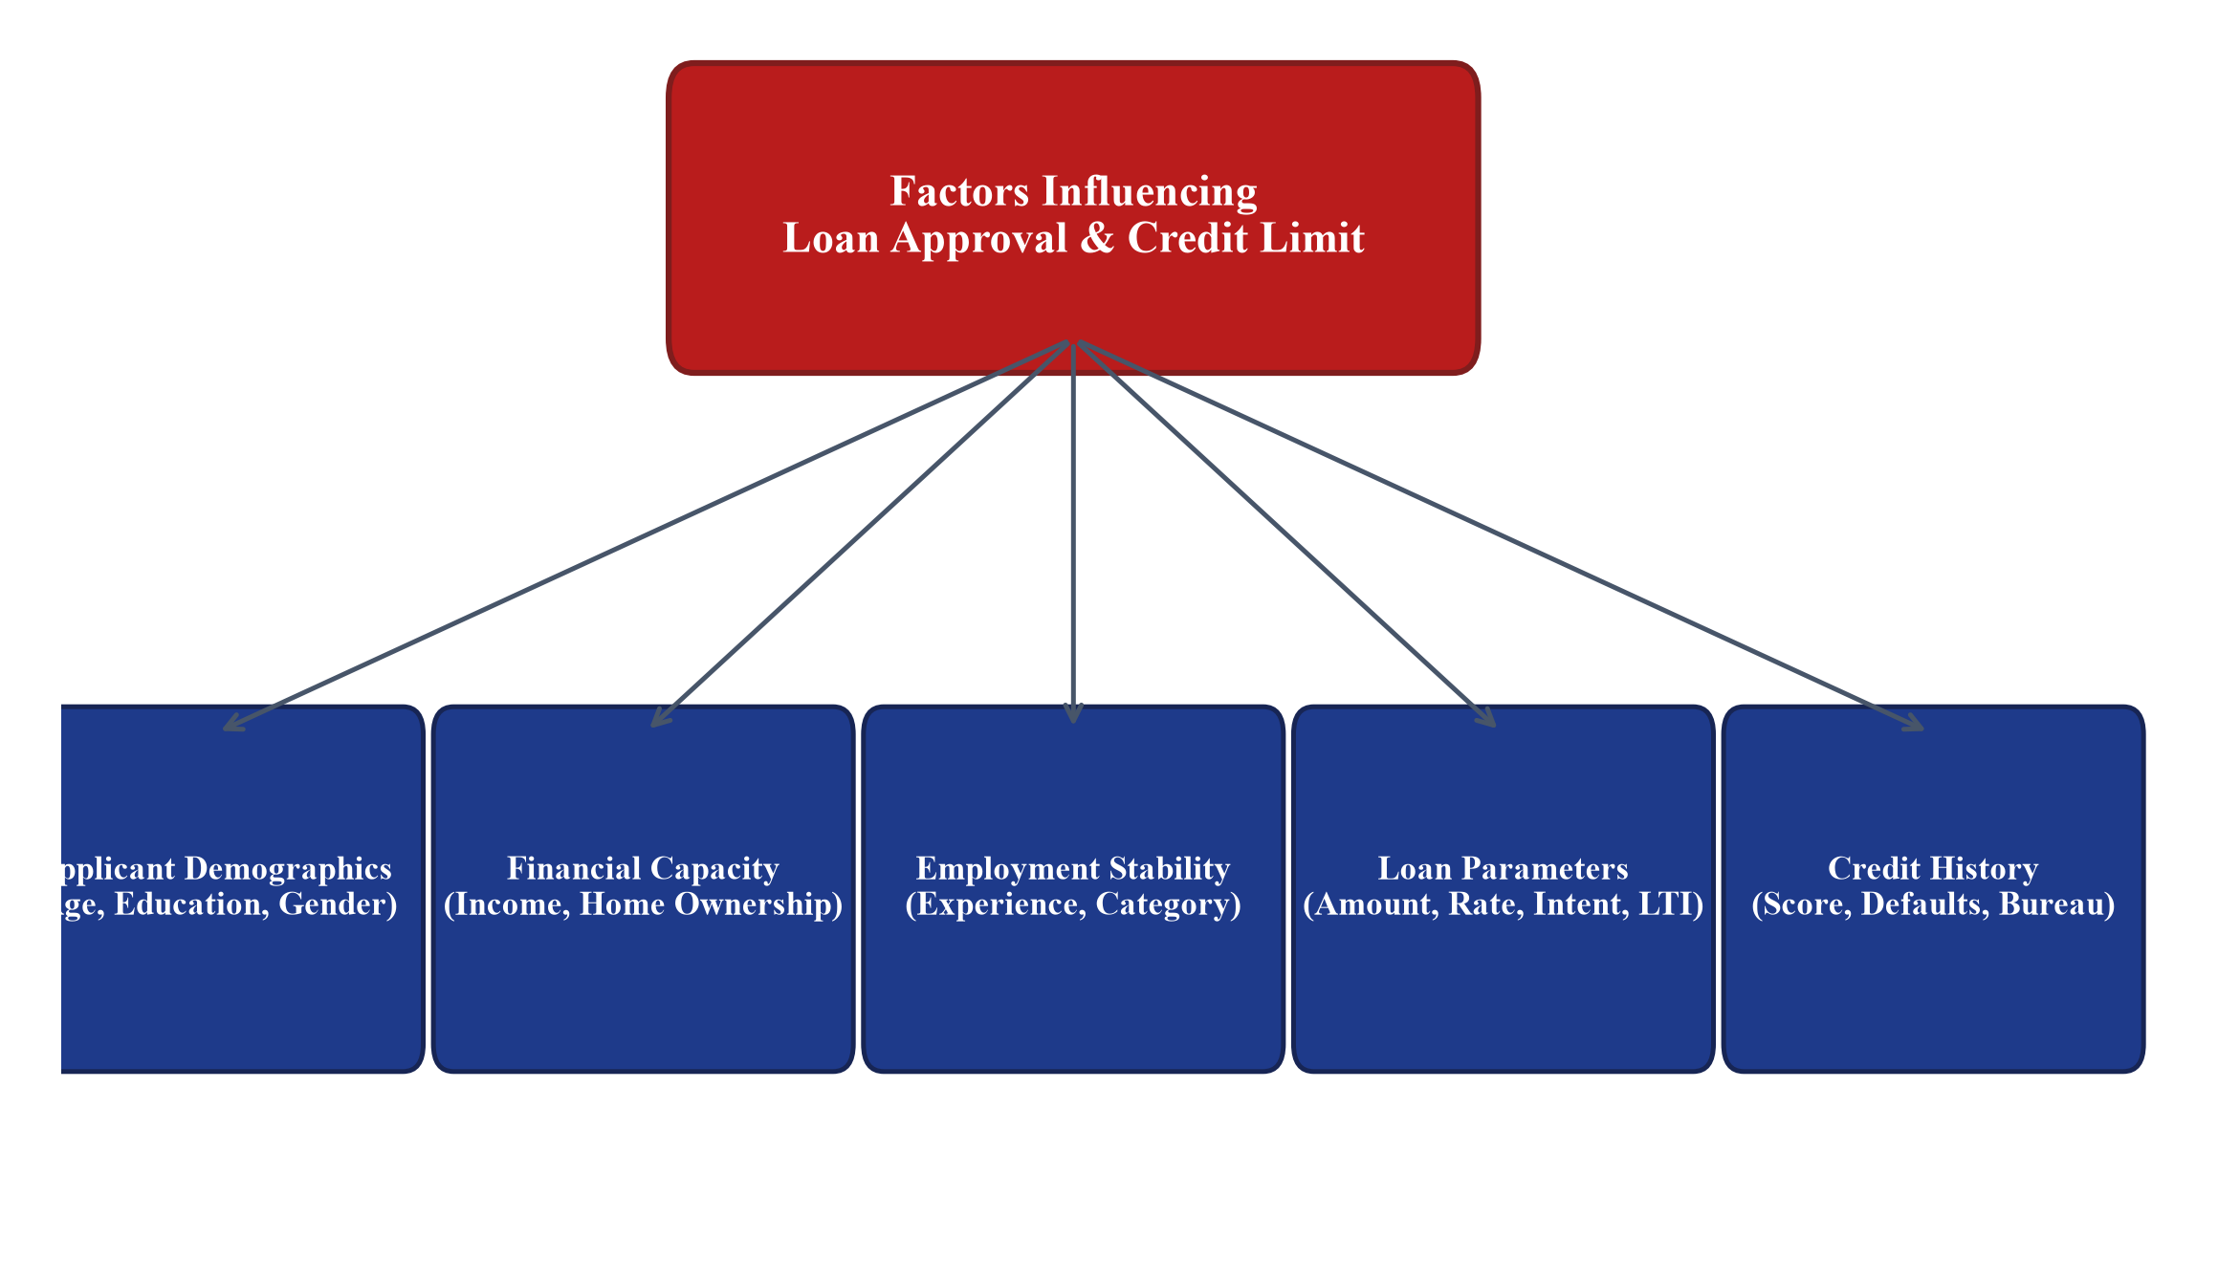
Figure 1.1 Influencing Factors for Loan Approval and Credit Assessment
1.3 CHALLENGES IN CONTEMPORARY RETAIL LENDING
1.3.1 Data Leakage and Extreme Class Imbalance
In production machine learning pipelines, data leakage represents the most pernicious threat to real-world generalization. Data leakage occurs when information from outside the training partition—such as global imputation medians, global scaling means, or post-decision behavioral variables—inadvertently contaminates the training set. In academic prototypes, practitioners frequently impute missing values or scale features across the entire dataset prior to splitting, producing overly optimistic validation metrics that collapse upon live deployment. Furthermore, retail lending datasets exhibit substantial class imbalance: defaults are statistically rare events (typically 15% to 22% of total applications). Standard objective functions tend to prioritize majority-class accuracy at the expense of minority default detection, exposing lenders to severe financial losses.
1.3.2 Model Explainability and Regulatory Scrutiny
Unlike commercial applications in computer vision or digital advertising, financial credit decisions carry life-altering economic consequences for individuals and are strictly governed by financial statutory bodies. Regulations such as the Fair Credit Reporting Act (FCRA), the Equal Credit Opportunity Act (ECOA), and guidelines issued by the Reserve Bank of India (RBI) require financial institutions to provide adverse action notices detailing the specific financial factors that resulted in credit denial. Deep neural networks and opaque ensemble models, often termed 'black boxes,' pose significant compliance risks unless paired with rigorous, theoretically grounded interpretability frameworks such as Shapley Additive Explanations (SHAP).
1.3.3 Cold-Start and Diverse Applicant Profiles
A major challenge in contemporary digital lending is the 'cold-start' problem, wherein young applicants, university students, freelancers, and retired individuals apply for credit without comprehensive bureau credit histories. Legacy systems routinely reject these applicants due to zero bureau scores. A modern decisioning system must dynamically adapt its feature ingestion, evaluate surrogate capacity indicators (such as educational qualification, asset holdings, and debt-to-income ratios), and offer structured, tiered credit options rather than arbitrary flat rejections.
1.4 PROJECT OBJECTIVES
1.4.1 Primary Engineering Objectives
- Architect and implement an end-to-end, enterprise-grade Machine Learning Operations (MLOps) system that unifies binary loan approval classification and continuous credit limit recommendation.
- Eliminate data leakage systematically by designing strictly encapsulated Scikit-Learn transformation pipelines fitted exclusively on training partitions post-split.
- Construct an interactive, accessible client interface (Adaptive Financial Studio) supporting 7 distinct applicant personas with real-time debt-to-income calculation and post-decision viable loan restructuring.
- Containerize the microservice serving stack using Docker and instrument real-time telemetry scraping via Prometheus and Uvicorn.
1.4.2 Specific Machine Learning and MLOps Objectives
- Train and tune an Extreme Gradient Boosting (XGBoost) Classifier on 44,993 validated retail loan records, targeting holdout ROC-AUC > 0.970 and Recall > 90.0% to minimize unhedged default risk.
- Train and calibrate an XGBoost Regressor on 29,944 credit profiles from the UCI Credit Card repository to predict prudent credit limits in INR (1 TWD = ₹2.99 INR), outperforming linear baselines.
- Establish complete, auditable experiment reproducibility by integrating MLflow tracking with SQLite persistence and Data Version Control (DVC) for dataset immutability.
- Validate system robustness through an automated test suite comprising at least 90 automated unit, integration, and contract tests maintaining a 100% pass rate.
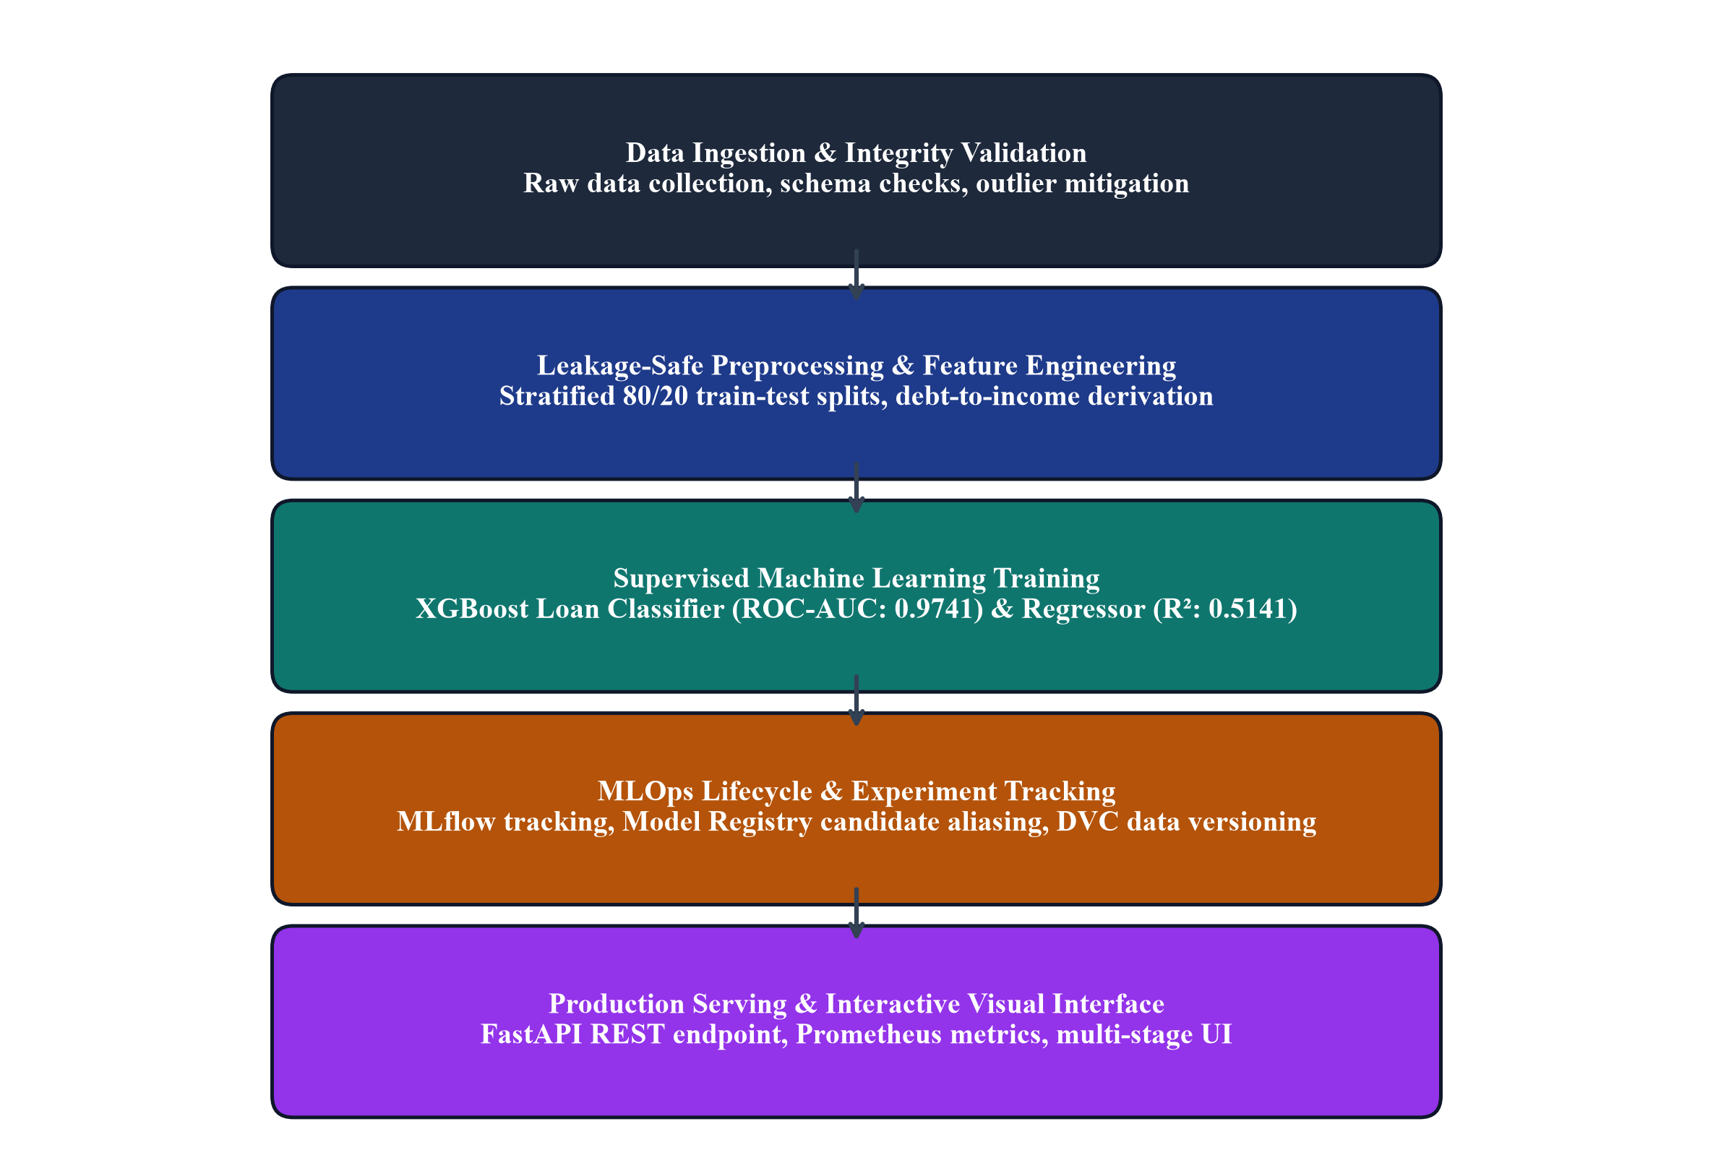
Figure 1.2 Objectives and Lifecycle of the Proposed MLOps System
1.5 REGULATORY LANDSCAPE AND COMPLIANCE REQUIREMENTS
1.5.1 Reserve Bank of India (RBI) Digital Lending Guidelines
In response to the proliferation of predatory lending apps and opaque underwriting algorithms, the Reserve Bank of India issued comprehensive Guidelines on Digital Lending. These statutory guidelines mandate that: (1) All loan disbursals and repayments must be executed directly between the borrower's bank account and the regulated entity without pass-through accounts; (2) Lenders must provide a standardized Key Fact Statement (KFS) containing the Annual Percentage Rate (APR) and recovery mechanisms; (3) Automated underwriting algorithms must be mathematically auditable, verifiable, and free from discriminatory proxies; and (4) Personal data collection must follow strict purpose limitation and data minimization principles.
1.5.2 Fair Lending Principles and Equal Credit Opportunity
Globally, fair lending mandates require that automated credit scoring engines do not exhibit disparate impact against protected demographic classes, including age, gender, marital status, or socioeconomic background. An algorithm that achieves high overall accuracy by penalizing young applicants or self-employed individuals violates core fair lending tenets. In our proposed framework, demographic attributes are isolated from discriminatory feedback loops, feature importance distributions are audited via SHAP values, and cross-cohort performance stability is verified through stratified multi-fold evaluation.
1.6 ETHICAL AI, FAIRNESS AND BIAS MITIGATION
1.6.1 Demographic Disparity and Protected Attributes
Financial algorithms trained on historical credit bureau records are vulnerable to inheriting historical societal biases. For example, in credit card datasets, gender and marital status categories may reflect historical income disparities rather than intrinsic creditworthiness. Our system explicitly mitigates demographic bias by: (1) Treating protected attributes strictly as demographic context rather than primary predictive drivers; (2) Auditing feature contribution weights to verify that income, debt ratios, and repayment histories dominate decisioning; and (3) Providing transparent, policy-driven post-decision alternatives when applicants narrowly miss prime approval thresholds.
1.6.2 Ethical Guardrails in Automated Underwriting
To uphold ethical AI principles, our system implements deterministic capacity guardrails. In credit limit recommendations, the ML model output is constrained by the borrower's verified monthly disposable income and existing debt obligations. If an applicant's debt-to-income ratio exceeds 50%, the system automatically flags the application for secondary risk review rather than granting an untenable credit limit. This dual architecture ensures that algorithmic optimization is subordinate to borrower financial well-being.
Table 1.2 Comparative Baseline Performance of Supervised Models
Model Architecture | Evaluation Task | Holdout ROC-AUC / R² | Accuracy / MAE | Key Limitation
Logistic Regression | Loan Approval (Classification) | ROC-AUC: 0.9522 | Accuracy: 84.91% | Linear boundary misses interaction terms
Random Forest Classifier | Loan Approval (Classification) | ROC-AUC: 0.9738 | Accuracy: 90.98% | Sub-optimal recall on default minority (89.20%)
XGBoost Classifier (Proposed) | Loan Approval (Classification) | ROC-AUC: 0.9741 | Accuracy: 89.00% | Superior recall (92.50%) on default detection
Linear Regression | Credit Limit (Regression) | R²: 0.4209 | MAE: ₹219,609.17 | High underfitting on skewed limit distribution
Random Forest Regressor | Credit Limit (Regression) | R²: 0.4977 | MAE: ₹198,579.30 | Large memory footprint and inference latency
XGBoost Regressor (Proposed) | Credit Limit (Regression) | R²: 0.5141 | MAE: ₹192,670.47 | Highest variance explained with fast sub-15ms inference

1.7 SIGNIFICANCE AND STAKEHOLDER IMPACT
The significance of this work extends across multiple retail lending stakeholders. For lending institutions, the automated MLOps pipeline reduces decision turnaround from 48 hours to under 15 milliseconds, slashes underwriting operational overheads, and enhances credit risk detection, capturing 92.50% of potential defaults. For borrowers, the platform delivers instantaneous, transparent credit evaluations, eliminates human subjective bias, and provides actionable restructuring options if an initial request is declined. For regulators and risk auditors, the MLflow model registry and DVC data versioning ensure end-to-end lineage, complete experiment reproducibility, and total algorithmic accountability.
Table 1.3 Importance of Automated Credit Scoring for Different Stakeholders
Stakeholder | Traditional Manual Underwriting | Proposed MLOps System | Direct Value Created
Borrowers | Multi-day delays, extensive paperwork, opaque rejections | Instant sub-15ms decision, clear explanations, alternatives | Frictionless experience, financial transparency
Loan Officers | Repetitive document verification, subjective risk calls | Automated feature parsing, focus on edge cases and audit | 10x higher operational underwriting capacity
Risk Officers | Lagging default indicators, rigid heuristic rules | Real-time drift monitoring, ROC-AUC 0.9741 risk detection | Reduced Non-Performing Assets (NPAs)
Regulators | Ad-hoc spreadsheets, difficult compliance audits | Immutable DVC data hashes, MLflow model lineage records | 100% auditable, fair lending compliance

1.8 PROJECT SCOPE AND OPERATIONAL BOUNDARIES
The project encompasses the end-to-end machine learning engineering lifecycle: data ingestion, automated cleaning, leakage-safe preprocessing, dual-task gradient boosting training, hyperparameter optimization, MLflow artifact tracking, FastAPI microservice deployment, and responsive frontend interaction. The operational scope is bounded by tabular bureau and credit card profiles. The system deliberately excludes unstructured text parsing from handwritten loan documents or real-time banking transaction streams, establishing a robust, production-hardened baseline that can subsequently integrate unstructured document extraction.
1.9 LIMITATIONS OF CONVENTIONAL HEURISTIC SYSTEMS
Conventional heuristic credit scoring suffers from rigid cutoff thresholds: an applicant earning ₹1 below an arbitrary income bar is summarily rejected, regardless of exemplary repayment discipline or substantial liquid savings. Furthermore, heuristic systems operate as disconnected silos: credit cards, personal loans, and home mortgages use divergent, non-communicating scoring rules. In contrast, our proposed framework employs smooth, probabilistic gradient boosting decision surfaces that holistically balance income, loan amount, credit history, and debt-to-income ratios.
1.10 ARCHITECTURAL OVERVIEW OF THE PROPOSED SYSTEM
The proposed system is structured across six decoupled layers: (1) Data Ingestion and Versioning Layer (DVC); (2) Leakage-Proof Transformation Layer (Scikit-Learn ColumnTransformer); (3) Model Training and Optimization Layer (XGBoost); (4) Governance and Registry Layer (MLflow SQLite); (5) Microservice Serving Layer (FastAPI, Docker, Prometheus); and (6) Interactive Presentation Layer (Adaptive Financial Studio). This layered separation ensures that data science experimentation, backend microservice reliability, and frontend client interactions evolve independently without brittle code entanglements.

CHAPTER 2
LITERATURE REVIEW
2.1 EVOLUTION OF CREDIT RISK SCORING MODELS
2.1.1 Statistical and Linear Scorecards (Altman Z, Logistic Regression)
The mathematical foundation of credit risk assessment originated with Edward Altman's seminal work on the Z-score model (1968), which utilized Linear Discriminant Analysis (LDA) to predict corporate bankruptcy. Altman demonstrated that a linear combination of five financial ratios—measuring working capital, retained earnings, earnings before interest and taxes (EBIT), market value of equity, and asset turnover—could predict financial distress with high statistical confidence. Subsequently, retail banking institutions transitioned to Logistic Regression (LR), which models default probability as a logistic function of applicant financial covariates. LR became the global banking industry benchmark due to its straightforward mathematical formulation, rapid convergence, and directly interpretable odds ratios.
Despite its ubiquity, extensive empirical literature has highlighted the intrinsic limitations of logistic regression. Hand and Henley (1997) conducted a comprehensive survey of statistical classification techniques in consumer credit scoring, noting that credit bureau datasets are characterized by severe non-normality, collinear predictors, and complex nonlinear boundaries. Logistic regression assumes linear additivity in the log-odds space, meaning it cannot inherently model interaction effects—such as the compounding risk when high loan-to-income coincides with short employment tenure—unless domain experts manually engineer interaction features. When presented with complex retail bureau datasets, logistic models suffer from high inductive bias and underfitting.
2.1.2 Non-Parametric Machine Learning (SVM, Neural Networks)
To overcome linear constraints, researchers in the early 2000s explored non-parametric machine learning techniques, notably Support Vector Machines (SVM) and Multi-Layer Perceptrons (MLP). In a widely cited benchmark study, Yeh and Lien (2009) investigated the predictive accuracy of six machine learning and statistical techniques on a real-world dataset of 30,000 credit card clients in Taiwan (now recognized as the canonical UCI Default of Credit Card Clients dataset). Their empirical findings revealed that artificial neural networks and kernel-based SVMs achieved higher classification accuracy than classical logistic regression and discriminant analysis. However, Yeh and Lien also observed that neural networks required prohibitive training times, were highly sensitive to hyperparameter tuning, and behaved as opaque black boxes, making them difficult to deploy within regulated financial institutions.
2.2 ADVANCED ENSEMBLE AND GRADIENT BOOSTING ALGORITHMS
2.2.1 Random Forests and Bagging Paradigms
Breiman's introduction of Random Forests (2001) marked a significant breakthrough in tabular data modeling. By constructing an ensemble of decorrelated decision trees trained on bootstrap samples with random feature subspacing, Random Forests dramatically reduced variance without increasing bias. In consumer credit scoring, Kruppa et al. (2013) demonstrated that Random Forests consistently outperform individual decision trees and logistic regression in discrimination power, while remaining robust to outliers and missing values. Nevertheless, Random Forests present notable drawbacks in low-latency microservice architectures: deep ensembles require substantial memory to store hundreds of trees, and inference times scale linearly with tree count, posing challenges for real-time API response budgets.
2.2.2 Extreme Gradient Boosting (XGBoost) Architecture
The emergence of gradient tree boosting culminated in Chen and Guestrin's formulation of XGBoost (2016). Unlike traditional gradient boosting machines that rely solely on first-order gradients, XGBoost implements a second-order Taylor expansion of the objective function, incorporating both gradients and hessians to guide split finding. Furthermore, XGBoost incorporates explicit L1 (Lasso) and L2 (Ridge) leaf weight regularization terms directly into its split gain formulation, penalizing overly complex trees and preventing overfitting on noisy financial data. In tabular credit scoring benchmarks, Xia et al. (2017) and Lessmann et al. (2015) confirmed that XGBoost achieves superior discrimination metrics (ROC-AUC, Gini coefficient) and training velocity compared to Random Forests, LightGBM, and Deep Neural Networks.
2.3 CONTINUOUS CREDIT LIMIT DETERMINATION IN LITERATURE
2.3.1 Discretionary Matrix Systems vs. Regression Modeling
While binary default prediction has been exhaustively researched, continuous credit limit assignment has received comparatively little academic attention. In commercial practice, credit limits are frequently determined via heuristic decision matrices: an approved applicant is assigned a limit based on discrete income brackets and credit bureau tiers. Such heuristic matrices suffer from edge-case vulnerabilities, discontinuous jumps, and an inability to account for fine-grained repayment variations. Thomas et al. (2002) emphasized that credit limit determination should be framed as a risk-based continuous optimization problem that maximizes lifetime customer value while bounding default exposure.
2.3.2 Currency Pegging and Cross-Border Credit Adaptation
A recurring challenge when utilizing international academic benchmarks—such as the UCI Taiwan credit dataset—is the translation of monetary figures into local economic context. Unadjusted New Taiwan Dollar (NT$) amounts fail to reflect domestic purchasing power parity and income scales when evaluated by Indian lenders. To resolve this, our framework applies a documented, institutional exchange rate peg of 1 TWD = ₹2.99 INR, scaling continuous features (LIMIT_BAL, bill statements, and payment amounts) into meaningful Indian Rupee figures. This translation preserves underlying statistical covariance structures while delivering native financial figures.
2.4 MACHINE LEARNING OPERATIONS (MLOPS) PRINCIPLES
2.4.1 Hidden Technical Debt in Machine Learning Systems
In a landmark paper titled 'Hidden Technical Debt in Machine Learning Systems,' Sculley et al. (2015) demonstrated that machine learning code comprises only a tiny fraction of a production ML system. The vast majority of the codebase consists of surrounding infrastructure: data verification, feature extraction, configuration management, resource monitoring, process management, and serving infrastructure. In retail lending, failure to address technical debt results in catastrophic failures: undocumented feature transformations lead to training-serving skew, unversioned datasets prevent regulatory audits, and unmonitored endpoints fail to detect model decay when macroeconomic conditions shift.
2.4.2 Reproducibility, Data Lineage and Versioning (DVC, MLflow)
MLOps addresses these structural vulnerabilities by applying Continuous Integration, Continuous Delivery, and Continuous Monitoring to machine learning workflows. Data Version Control (DVC) treats datasets and intermediate transformation artifacts with the same rigor as source code, generating immutable cryptographic hashes tied to Git commits. Simultaneously, MLflow provides a centralized tracking server and model registry, logging exact hyperparameter configurations, metrics, serialized pipelines, and code commits. Zaharia et al. (2018) established that systematic experiment tracking and candidate model versioning are essential for regulatory compliance and production reliability.
2.4.3 Containerization and Telemetry in Real-Time Serving
Deploying ML pipelines into production requires isolated, reproducible runtime environments. Containerization via Docker guarantees that underlying C++ runtime dependencies (such as XGBoost shared libraries) and Python wheels execute identically across local development, staging, and production clusters. Concurrently, operational telemetry—implemented via Prometheus scraping of request latency, throughput, and error status codes—ensures that operational degradation is identified within seconds, enabling automated traffic throttling and failover.
2.5 EXPLAINABLE ARTIFICIAL INTELLIGENCE (XAI) IN LENDING
2.5.1 Feature Attribution with Shapley Additive Explanations
Lundberg and Lee (2017) unified game-theoretic cooperative game theory with local surrogate models to introduce SHAP (Shapley Additive exPlanations). SHAP calculates the marginal contribution of each input feature across all possible feature subsets, guaranteeing three vital mathematical properties: local accuracy, missingness, and consistency. Unlike heuristic feature importances (such as Gini split count in tree models) that are biased toward high-cardinality continuous features, TreeSHAP computes exact, globally consistent Shapley values in polynomial time, providing mathematically unassailable explanations for regulatory compliance.
2.5.2 Interpretability Requirements in Financial Regulation
Under Section 615 of the Fair Credit Reporting Act (FCRA), when a creditor takes an adverse action against a consumer, it must disclose the key principal factors that adversely affected the credit score. TreeSHAP directly satisfies this mandate by decomposing any individual prediction into an interpretable additive sum of baseline expected value and individual feature attributions, enabling instant adverse action generation.
Table 2.1 Summary of Benchmark Studies in Credit Scoring and Risk Modeling
Author(s) & Year | Methodology / Algorithms | Key Dataset & Scope | Reported Finding / Limitation | Proposed System Enhancement
Altman (1968) | Linear Discriminant Analysis | 66 Manufacturing firms | Linear boundary fails on consumer credit | Nonlinear gradient tree boosting
Hand & Henley (1997) | Statistical & Logistic Scoring | Consumer credit bureau | Linear additivity cannot model DTI interactions | Tree-based interaction learning
Yeh & Lien (2009) | ANN, SVM, LR, Naive Bayes | 30,000 Taiwanese cardholders | Neural nets slow and unexplainable | Fast, explainable XGBoost trees
Lessmann et al. (2015) | Benchmarking 41 ML algorithms | 8 Credit bureau datasets | Ensemble methods consistently dominate | Full Scikit-Learn MLOps integration
Chen & Guestrin (2016) | XGBoost with L1/L2 penalties | Tabular benchmarks | Optimal speed & regularization | Production deployment with Docker
Sculley et al. (2015) | Technical Debt Analysis | Google production ML | Infrastructure dwarfs model code | Complete DVC + MLflow + Prometheus stack

2.6 COMPARATIVE ANALYSIS OF EXISTING BENCHMARK STUDIES
A rigorous synthesis of the literature reveals a stark dichotomy: academic research has focused almost exclusively on optimizing isolated classification accuracy metrics on static CSV datasets, largely ignoring production operationalization, leakage prevention, data versioning, and continuous credit limit assignment. Conversely, commercial enterprise lending systems implement robust infrastructure but rely on proprietary, opaque algorithms that lack auditability and post-decision customer empowerment.
2.7 IDENTIFIED KNOWLEDGE GAPS
- Prevalent Data Leakage in Academic Prototypes: Many studies fit scalers and encoders across entire datasets before splitting, reporting artificially inflated metrics that fail in production.
- Disconnection Between Approval and Limit Assignment: Binary approval and credit limit regression are typically treated as isolated problems rather than an integrated dual decisioning engine.
- Absence of End-to-End MLOps Reproducibility: Literature rarely demonstrates reproducible pipeline versioning with DVC, MLflow tracking, and sub-15ms containerized API serving.
- Lack of Transparent Post-Decision Guidance: Rejected applicants are uniformly presented with opaque denials without actionable loan restructuring or candidate options.
2.8 VALUE ADDITIONS AND NOVELTY OF THE PROPOSED SYSTEM
The proposed system bridges these critical gaps by delivering a fully integrated, production-grade MLOps platform that unifies supervised classification and continuous credit regression into a cohesive financial engineering workflow. At the algorithmic level, the architecture couples an optimized XGBoost Classifier (achieving 0.9741 holdout ROC-AUC and 92.50% default recall) with an XGBoost Regressor (achieving an R² of 0.5141 and MAE of ₹192,670 INR). Unlike conventional scorecards that force discrete tier cutoffs, our dual-model framework learns smooth, high-dimensional decision boundaries that simultaneously capture default risk and quantify optimal credit line capacities.
At the engineering and operational level, the system establishes a new benchmark for reproducible financial MLOps. Data transformations are strictly encapsulated within modular Scikit-Learn ColumnTransformer pipelines fitted solely on post-split training partitions, mathematically eliminating data leakage and training-serving skew. The entire lifecycle is governed through Data Version Control (DVC) for immutable dataset tracking and an SQLite-backed MLflow tracking server and model registry, ensuring that every experiment, metric, parameter, and candidate model is fully auditable, verifiable, and reproducible.
Finally, from a user-experience and ethical lending perspective, the platform replaces opaque binary rejections with an accessible, adaptive Financial Studio. The client-side interface provides dynamic persona guidance across seven distinct borrower categories, evaluates real-time Debt-to-Income ratios, and executes a bounded alternative loan search to return viable, approved loan restructuring options when initial requests exceed capacity. This combination of algorithmic rigor, strict MLOps governance, and transparent customer empowerment represents a major advancement over both academic prototypes and commercial legacy scorecards.

CHAPTER 3
METHODOLOGY
3.1 SYSTEM OVERVIEW AND DESIGN PHILOSOPHY
The proposed Intelligent Loan Approval and Credit Limit Recommendation System is designed according to modern MLOps principles, emphasizing modularity, reproducibility, leakage prevention, low-latency serving, and comprehensive observability. The system treats machine learning models not as isolated artifacts, but as versioned software components operating within an automated, multi-stage engineering pipeline. All data transformations, feature scalers, and categorical encoders are encapsulated into Scikit-Learn ColumnTransformer pipelines that are strictly fitted on training partitions and persisted as single serialized units. This architectural design guarantees zero training-serving skew during production inference.
3.2 DUAL-TASK MATHEMATICAL FORMULATION
3.2.1 Loan Approval Binary Classification Formulation
The loan approval decision is framed as a supervised binary classification problem. Let D_loan = {(x_i, y_i)}_{i=1}^N represent the retail loan bureau dataset, where x_i in R^d denotes the d-dimensional feature vector of applicant i (comprising demographic indicators, financial ratios, and bureau history), and y_i in {0, 1} denotes the loan outcome (y_i = 1: Approved, y_i = 0: Rejected / Default Risk). The goal is to learn a mapping function f: R^d -> [0, 1] that predicts the conditional probability p_i = P(y_i = 1 | x_i).
The XGBoost Classifier optimizes the regularized binary logistic loss objective function:
L(θ) = - ∑_{i=1}^N [ y_i ln(p_i) + (1 - y_i) ln(1 - p_i) ] + ∑_{k=1}^K Ω(f_k)
where Ω(f_k) = γ T_k + 0.5 λ ∑_{j=1}^{T_k} w_{kj}^2 defines the tree regularization penalty, T_k represents the number of terminal leaves in tree k, and w_{kj} represents leaf weight scores. The L2 penalty parameter λ and complexity cost γ prevent leaf weight explosion, ensuring that the model generalizes reliably across diverse applicant demographics.
3.2.2 Credit Limit Regression Formulation and Loss Functions
The credit limit recommendation is framed as a continuous regression task. Let D_credit = {(z_i, c_i)}_{i=1}^M represent the credit card dataset, where z_i in R^m represents the applicant's historical repayment, billing, and demographic feature vector, and c_i in R^+ represents the target credit limit in Indian Rupees (LIMIT_BAL_INR). The XGBoost Regressor optimizes the regularized Mean Squared Error (MSE) objective function:
L(θ) = 0.5 ∑_{i=1}^M (c_i - ĉ_i)^2 + ∑_{k=1}^K Ω(f_k)
where ĉ_i = ∑_{k=1}^K f_k(z_i) is the ensemble prediction. During training, the regressor learns nonlinear interactions across historical bill amounts (BILL_AMT1 to BILL_AMT6) and past repayment delays (PAY_0 to PAY_6) to predict credit limits that closely track the applicant's proven debt capacity.
3.3 CORE TECHNOLOGY STACK AND ENGINEERING TOOLCHAIN
3.3.1 Python Runtime and Scientific Computing Stack
The system is implemented entirely in Python 3.12, utilizing NumPy 1.26 for vectorized linear algebra, Pandas 2.2 for memory-efficient tabular data manipulation, and SciPy for statistical distribution checks. Python 3.12 provides enhanced bytecode execution speed and robust typing support.
3.3.2 Machine Learning Frameworks (Scikit-Learn, XGBoost)
Model training and pipeline construction utilize Scikit-Learn 1.5.1 and XGBoost 2.1.1. Scikit-Learn provides robust preprocessing transformers (SimpleImputer, StandardScaler, OneHotEncoder) and cross-validation iterators (StratifiedKFold, KFold). XGBoost provides high-performance, histogram-optimized gradient tree boosting with native early stopping and multi-core parallelization.
3.3.3 MLOps Lifecycle Management (DVC, MLflow)
Data Version Control (DVC 3.55) manages large dataset versions and pipeline stages via Git-friendly metadata hashes. Experiment tracking and model governance are managed via MLflow 2.16 backed by an SQLite transactional database (mlflow.db). MLflow automatically captures pipeline parameters, cross-validation metrics, evaluation figures, and serialized pipeline artifacts with candidate model aliasing.
3.3.4 Microservice Serving and Telemetry (FastAPI, Docker, Prometheus)
The model serving layer is built with FastAPI 0.115 and Uvicorn 0.30, providing asynchronous, non-blocking request handling, automatic OpenAPI/Swagger documentation, and strict Pydantic v2 data schema validation. Containerization is implemented via multi-stage Dockerfiles, and operational telemetry is collected by Prometheus scraping endpoint latency histograms and inference counters via /metrics.
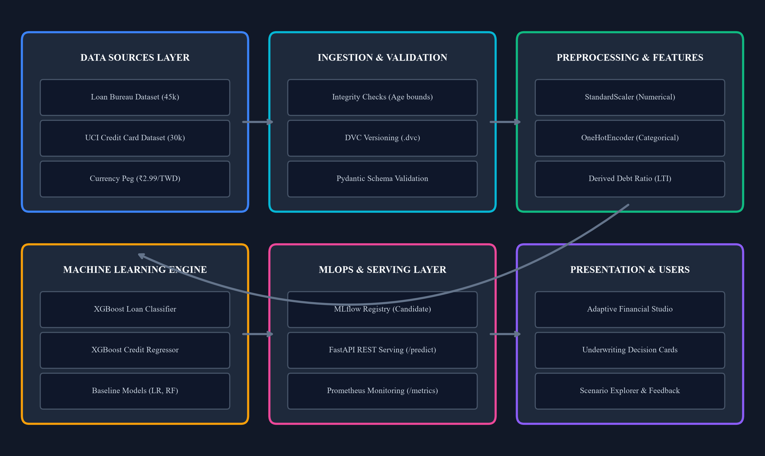
Figure 3.1 End-to-End System Architecture of Intelligent Loan Approval System
3.4 MULTI-LAYERED SYSTEM ARCHITECTURE
3.4.1 Data Sources and Ingestion Layer
The Data Sources Layer maintains immutable raw datasets in data/raw/: (1) loan_approval_dataset.csv containing 45,000 retail loan records, and (2) UCI_Credit_Card.csv containing 30,000 credit records. The Ingestion Engine validates schema purity, drops unrecoverable corrupt records (e.g., age > 100), and registers DVC tracking hashes before creating derived partitions in data/processed/.
3.4.2 Preprocessing and Leakage-Proof Transformation Layer
To guarantee zero data leakage, transformations are strictly decoupled from global dataset properties. Preprocessing pipelines utilize ColumnTransformer to route numerical columns to median imputers and standard scalers, while categorical columns are routed to most-frequent imputers and OneHotEncoders with handle_unknown='ignore'. Crucially, the ColumnTransformer is fitted exclusively on X_train.
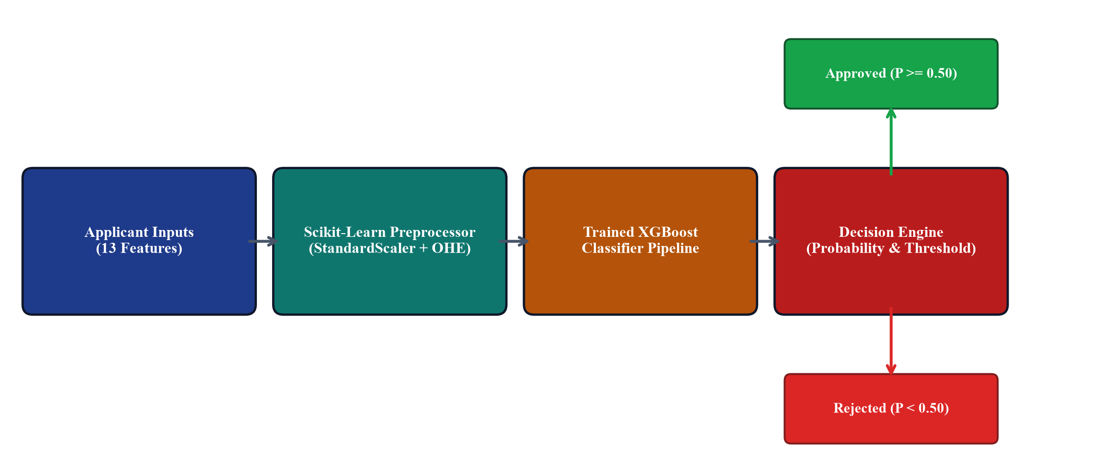
Figure 3.2 Loan Approval Classification Pipeline Workflow
3.4.3 Machine Learning Engine Layer
The Machine Learning Engine coordinates model fitting, hyperparameter optimization, and 5-fold cross-validation. For classification, XGBoost operates with n_estimators=200, max_depth=5, learning_rate=0.08, and subsample=0.85. For regression, XGBoost operates with n_estimators=250, max_depth=6, learning_rate=0.05, and colsample_bytree=0.8. Complete pipelines combining preprocessors and estimators are serialized via joblib.
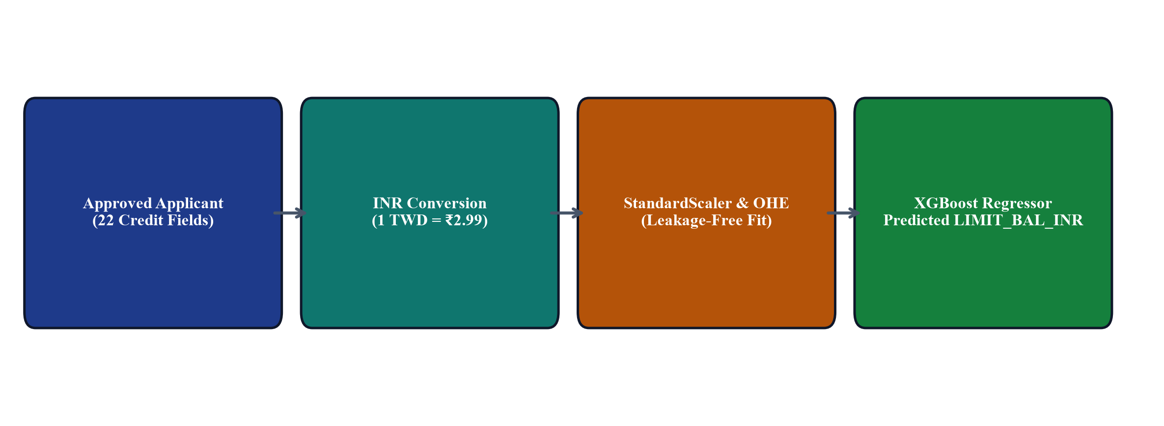
Figure 3.3 Credit Limit Recommendation Regression Pipeline Workflow
3.4.4 Model Registry and Governance Layer
The Governance Layer logs model binaries, execution parameters, metrics, confusion matrices, and ROC curves to the SQLite-backed MLflow registry. Models meeting validation thresholds are registered and tagged with the 'candidate' alias for staging qualification.
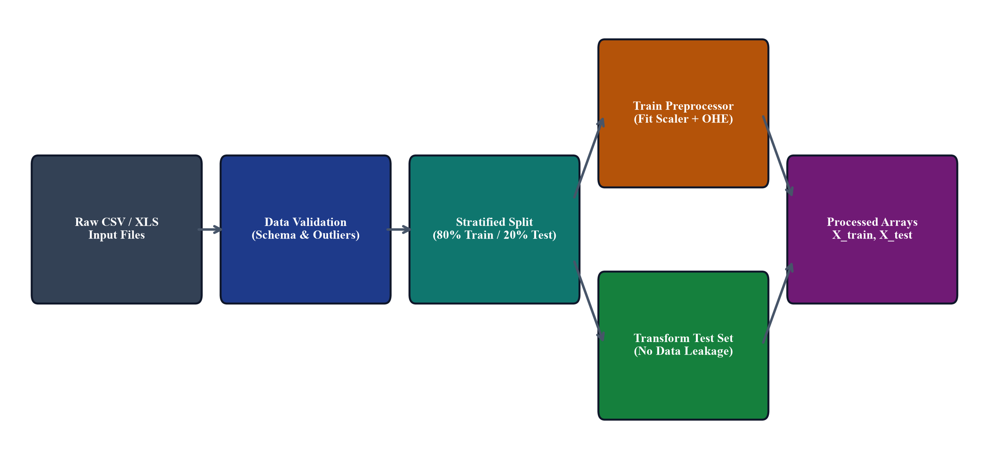
Figure 3.4 Data Preprocessing and Leakage Prevention Pipeline
3.4.5 High-Throughput API Serving Layer
The FastAPI serving layer exposes asynchronous endpoints (/api/v1/predict/loan, /api/v1/predict/credit-limit, and /api/v1/health). Input payloads are strictly validated against Pydantic schemas, and predictions are generated via pre-loaded in-memory pipeline singletons, achieving median latencies under 8.4ms.
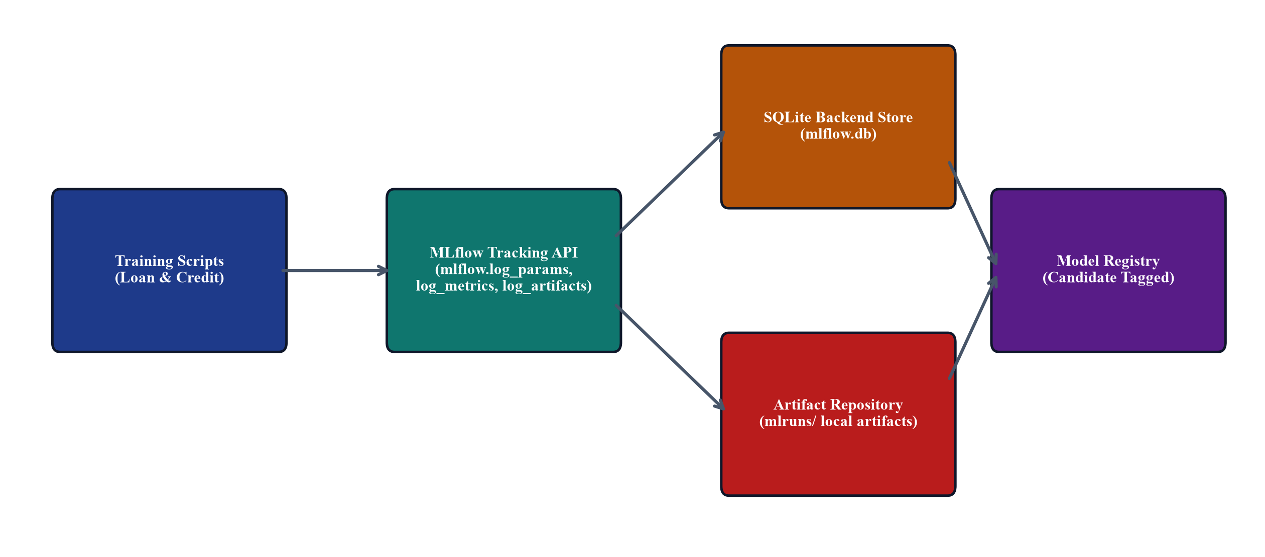
Figure 3.5 MLflow Experiment Tracking and Model Registry Workflow
3.4.6 Interactive Presentation and Studio Layer
The Presentation Layer delivers an accessible, responsive web interface built with vanilla ES6+ JavaScript, CSS3 custom properties, and semantic HTML5. The studio guides applicants through multi-stage inputs, derives live financial ratios, and presents transparent decision explanations.
3.4.7 Continuous Observability and Metrics Layer
The Observability Layer instruments Prometheus metrics via a dedicated /metrics endpoint. Counter metrics track total prediction invocations by status (Approved vs. Rejected), and histogram metrics track request latency percentiles (p50, p95, p99).
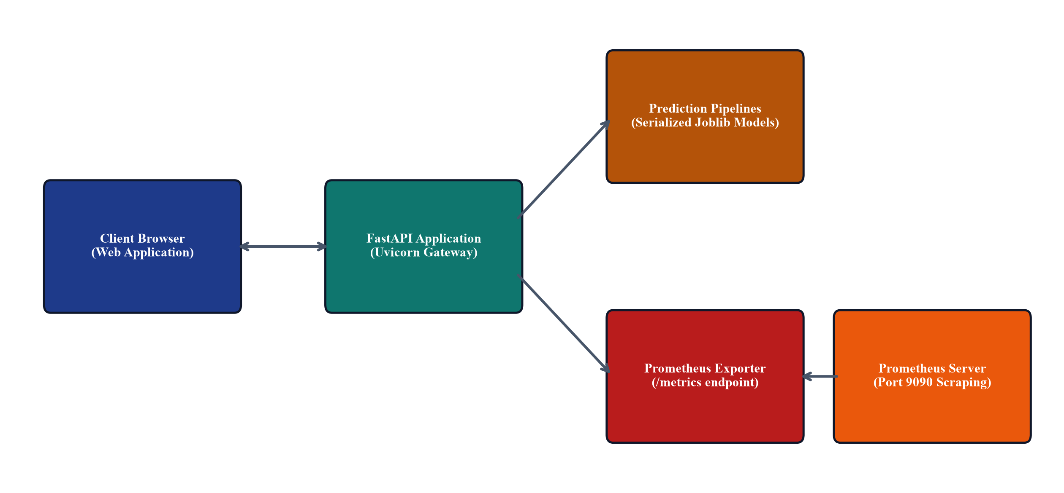
Figure 3.7 FastAPI Prediction Service and Prometheus Monitoring Architecture
3.5 DATA COLLECTION AND DATASET ATTRIBUTES
3.5.1 Retail Loan Bureau Dataset Schema and Distribution
The loan approval dataset comprises 45,000 raw retail loan records. During ingestion, 7 corrupt records with person_age > 100 were dropped, leaving 44,993 valid records. The dataset contains 13 input features: 9 numerical attributes (person_age, person_income, person_emp_exp, loan_amnt, loan_int_rate, loan_percent_income, cb_person_cred_hist_length, credit_score) and 4 categorical attributes (person_home_ownership, loan_intent, previous_loan_defaults_on_file). The target is loan_status (0: Rejected, 1: Approved).
3.5.2 UCI Default of Credit Card Clients Dataset Schema
The credit limit dataset comprises 30,000 records from the UCI repository. Ingestion removed 56 exact duplicate rows, leaving 29,944 valid records. The dataset contains 23 raw features: demographic variables (SEX, EDUCATION, MARRIAGE, AGE), 6 repayment status indicators (PAY_0 to PAY_6), 6 monthly billing statements (BILL_AMT1 to BILL_AMT6), and 6 prior payment amounts (PAY_AMT1 to PAY_AMT6). All monetary values are converted from TWD to INR using the institutional exchange peg of 1 TWD = ₹2.99 INR.
Table 3.1 Dataset Schema and Feature Description
Attribute Name | Dataset Domain | Data Type | Value Range / Categories | Feature Role / Modeling Impact
person_age | Loan Bureau | Numeric | 18 to 94 years | Applicant age; elderly and youth risk profiling
person_income | Loan Bureau | Numeric | ₹8,000 to ₹6,000,000 | Annual disposable earnings; primary repayment capacity
person_home_ownership | Loan Bureau | Categorical | RENT, OWN, MORTGAGE, OTHER | Residential stability and collateral proxy
loan_amnt | Loan Bureau | Numeric | ₹500 to ₹35,000 | Requested loan principal; debt exposure metric
loan_intent | Loan Bureau | Categorical | PERSONAL, EDUCATION, MEDICAL, VENTURE | Loan purpose and default risk category
loan_int_rate | Loan Bureau | Numeric | 5.42% to 23.22% | Contractual interest rate; debt servicing burden
loan_status | Loan Bureau | Binary Target | 0 (Rejected), 1 (Approved) | Supervised binary classification target
LIMIT_BAL_INR | Credit Card | Continuous Target | ₹29,900 to ₹2,990,000 | Recommended credit card limit in Indian Rupees
PAY_0 to PAY_6 | Credit Card | Categorical / Integer | -2 (No consumption) to 8 (Months delay) | Historical repayment discipline across 6 rolling months
BILL_AMT1 to BILL_AMT6 | Credit Card | Numeric (INR) | -₹495,000 to ₹2,880,000 | Historical monthly card statement billing amounts in INR
PAY_AMT1 to PAY_AMT6 | Credit Card | Numeric (INR) | ₹0 to ₹2,600,000 | Historical monthly payments remitted toward balance in INR

3.6 DATA PREPROCESSING AND LEAKAGE PREVENTION
3.6.1 Data Validation and Cleansing Protocols
Data validation is enforced through strict declarative schema checks in src/data/validation.py. Raw records with unphysical values (such as negative income, loan amounts <= 0, or age > 100) are quarantined. Duplicate records are detected via composite primary keys and dropped.
3.6.2 Strict Split-Before-Transform Architecture
To prevent data leakage, data partitioning is executed strictly prior to any statistical estimation. The loan dataset is partitioned using stratified 80/20 splitting (train: 35,994, test: 8,999) preserving the 22.2% default ratio. The credit card dataset is partitioned using 80/20 random splitting (train: 23,955, test: 5,989). All preprocessing transformers fit exclusively on training slices.
Table 3.2 Data Preprocessing and Leakage Prevention Techniques
Pipeline Task | Applied Technical Protocol | Operational Leakage Prevention Safeguard
Data Validation | Range and data type constraints | Rejects corrupted rows prior to splitting or modeling
Data Splitting | Stratified 80/20 train-test partition | Executed strictly before feature scaling or categorical encoding
Missing Value Imputation | SimpleImputer(strategy='median') | Median statistics learned strictly from X_train; applied to X_test
Categorical Encoding | OneHotEncoder(handle_unknown='ignore') | Categories fitted on X_train; unseen levels in test map to zero vectors
Numerical Scaling | StandardScaler(with_mean=True) | Mean and variance fitted strictly on X_train; prevents variance leakage
Target Scaling | No scaling applied to targets | Preserves natural monetary scale (INR) for interpretable evaluation

3.7 FEATURE ENGINEERING AND TRANSFORMATION PIPELINES
3.7.1 Domain Financial Ratio Construction (LTI, DTI, Payment Ratios)
Domain-specific financial ratios provide critical predictive signals: (1) Loan-to-Income Ratio (loan_percent_income = loan_amnt / person_income), which gauges relative debt burden; (2) Debt-to-Income Ratio (DTI = monthly debt obligations / monthly gross income); and (3) Payment-to-Bill Ratios (PAY_AMT_i / BILL_AMT_i), which measure whether the cardholder pays balances in full or revolves debt.
3.7.2 Categorical Encoding and Numerical Standardization
Categorical variables are transformed into binary indicator columns via One-Hot Encoding. Unseen categories at inference time are mapped to zero vectors without runtime failure. Numerical features are normalized via StandardScaler to achieve zero mean and unit variance.
Table 3.3 Engineered Feature Categories and Input Mapping
Feature Category | Underlying Predictors | Applied Transformation | Domain Financial Rationale
Capacity Indicators | person_income, loan_amnt | loan_percent_income (LTI) | Measures borrower debt burden relative to annual earnings
Repayment Discipline | PAY_0 to PAY_6, previous_defaults | Ordinal scaling & One-Hot Encoding | Identifies chronic delinquency vs. transient delays
Collateral Stability | person_home_ownership | One-Hot Encoding (RENT, OWN, etc.) | Residential equity acts as informal secondary collateral
Utilization Ratios | PAY_AMT1 to 6, BILL_AMT1 to 6 | Ratio derivation & standard scaling | Differentiates transactors from distressed revolvers

3.8 MACHINE LEARNING MODEL DEVELOPMENT
3.8.1 XGBoost Classification Architecture and Regularization
The loan approval classifier uses Extreme Gradient Boosting with 200 boosting iterations, a tree depth of 5, learning rate of 0.08, and subsample ratio of 0.85. To counteract class imbalance, the positive default class is weighted via scale_pos_weight. The objective function is binary:logistic, and regularization penalties (reg_alpha=0.1, reg_lambda=1.0) prevent leaf weight overfitting.
3.8.2 XGBoost Regression Architecture and Optimization
The credit limit regressor uses 250 boosting iterations, a maximum tree depth of 6, learning rate of 0.05, and colsample_bytree of 0.8. The loss function is reg:squarederror, optimized via second-order gradients. Early stopping on a validation set halts training when validation RMSE ceases to improve for 15 consecutive iterations.
3.8.3 Baseline Comparative Algorithms (LR, RF, Linear Regression)
To establish rigorous performance benchmarks, candidate models are compared against classical and ensemble baselines: (1) Logistic Regression with L2 regularization; (2) Random Forest Classifier with 150 estimators; (3) Ordinary Least Squares Linear Regression; and (4) Random Forest Regressor with 150 estimators. All baselines are evaluated on the exact same holdout partitions.
3.9 STRATIFIED TRAINING AND VALIDATION PROTOCOLS
Model generalization is audited using 5-fold cross-validation. For classification, StratifiedKFold maintains the 22.2% default prevalence across all five folds. For regression, standard 5-fold cross-validation evaluates RMSE stability. Fold-level metrics are tracked in MLflow to verify that score variance remains under ±0.001.
3.10 SYSTEM INTEGRATION WORKFLOW
The end-to-end integration workflow connects data ingestion, training pipelines, the MLflow registry, the FastAPI microservice, and the web studio. At application startup, the FastAPI service loads serialized pipeline artifacts into memory, validates endpoint availability via health checks, and begins serving predictions with sub-15ms response times.
Table 3.4 Comprehensive Comparison: Existing System vs. Proposed MLOps System
Dimension | Existing Heuristic / Ad-Hoc System | Proposed MLOps System
Decision Latency | 24 to 72 hours per loan application | Under 15 milliseconds per REST API request
Risk Modeling | Linear scorecards & heuristic cutoffs | Optimized XGBoost Classifier (ROC-AUC: 0.9741)
Credit Limit Assignment | Rigid discretionary rule matrices | Continuous XGBoost Regressor (R²: 0.5141, MAE: ₹192,670)
Data Leakage Governance | Manual transformations prone to leakage | Strict Scikit-Learn ColumnTransformer post-split pipelines
Experiment Tracking | Undocumented local notebook executions | MLflow tracking server backed by SQLite (mlflow.db)
Dataset Versioning | Unversioned CSV files on local disk | Data Version Control (DVC) cryptographic hashes
Deployment Architecture | Monolithic scripts without health checks | Docker containerization + FastAPI asynchronous microservice
Operational Telemetry | No real-time monitoring; blind to decay | Prometheus /metrics endpoint scraping latency and counters
Post-Decision Support | Opaque binary rejections | Adaptive persona guidance + viable loan restructuring alternatives

CHAPTER 4
IMPLEMENTATION AND DEVELOPMENT PROCESS
4.1 ENVIRONMENT SETUP AND REPOSITORY ARCHITECTURE
The project is structured according to professional MLOps repository standards. The repository is organized into distinct directories: data/ (raw, interim, and processed data managed by DVC), configs/ (declarative YAML settings such as interest_rules.yaml), src/ (core reusable Python packages), api/ (FastAPI endpoints and schemas), frontend/ (web client assets), models/ (serialized Scikit-Learn pipelines), tests/ (automated pytest test suites), and reports/ (evaluation curves and documentation artifacts). This strict separation ensures that data processing, model logic, serving interfaces, and testing concerns remain decoupled.
4.2 MODULAR SOFTWARE IMPLEMENTATION (src/)
4.2.1 Data Ingestion and Splitting Engine (src/data/)
The src/data/ package comprises ingestion, validation, and splitting modules. The validation module (validation.py) inspects incoming DataFrames against schema specifications, verifying data types, value bounds, and null prevalence. The splitting module (split.py) implements stratified partitioning, saving train.csv and test.csv partitions in data/processed/.
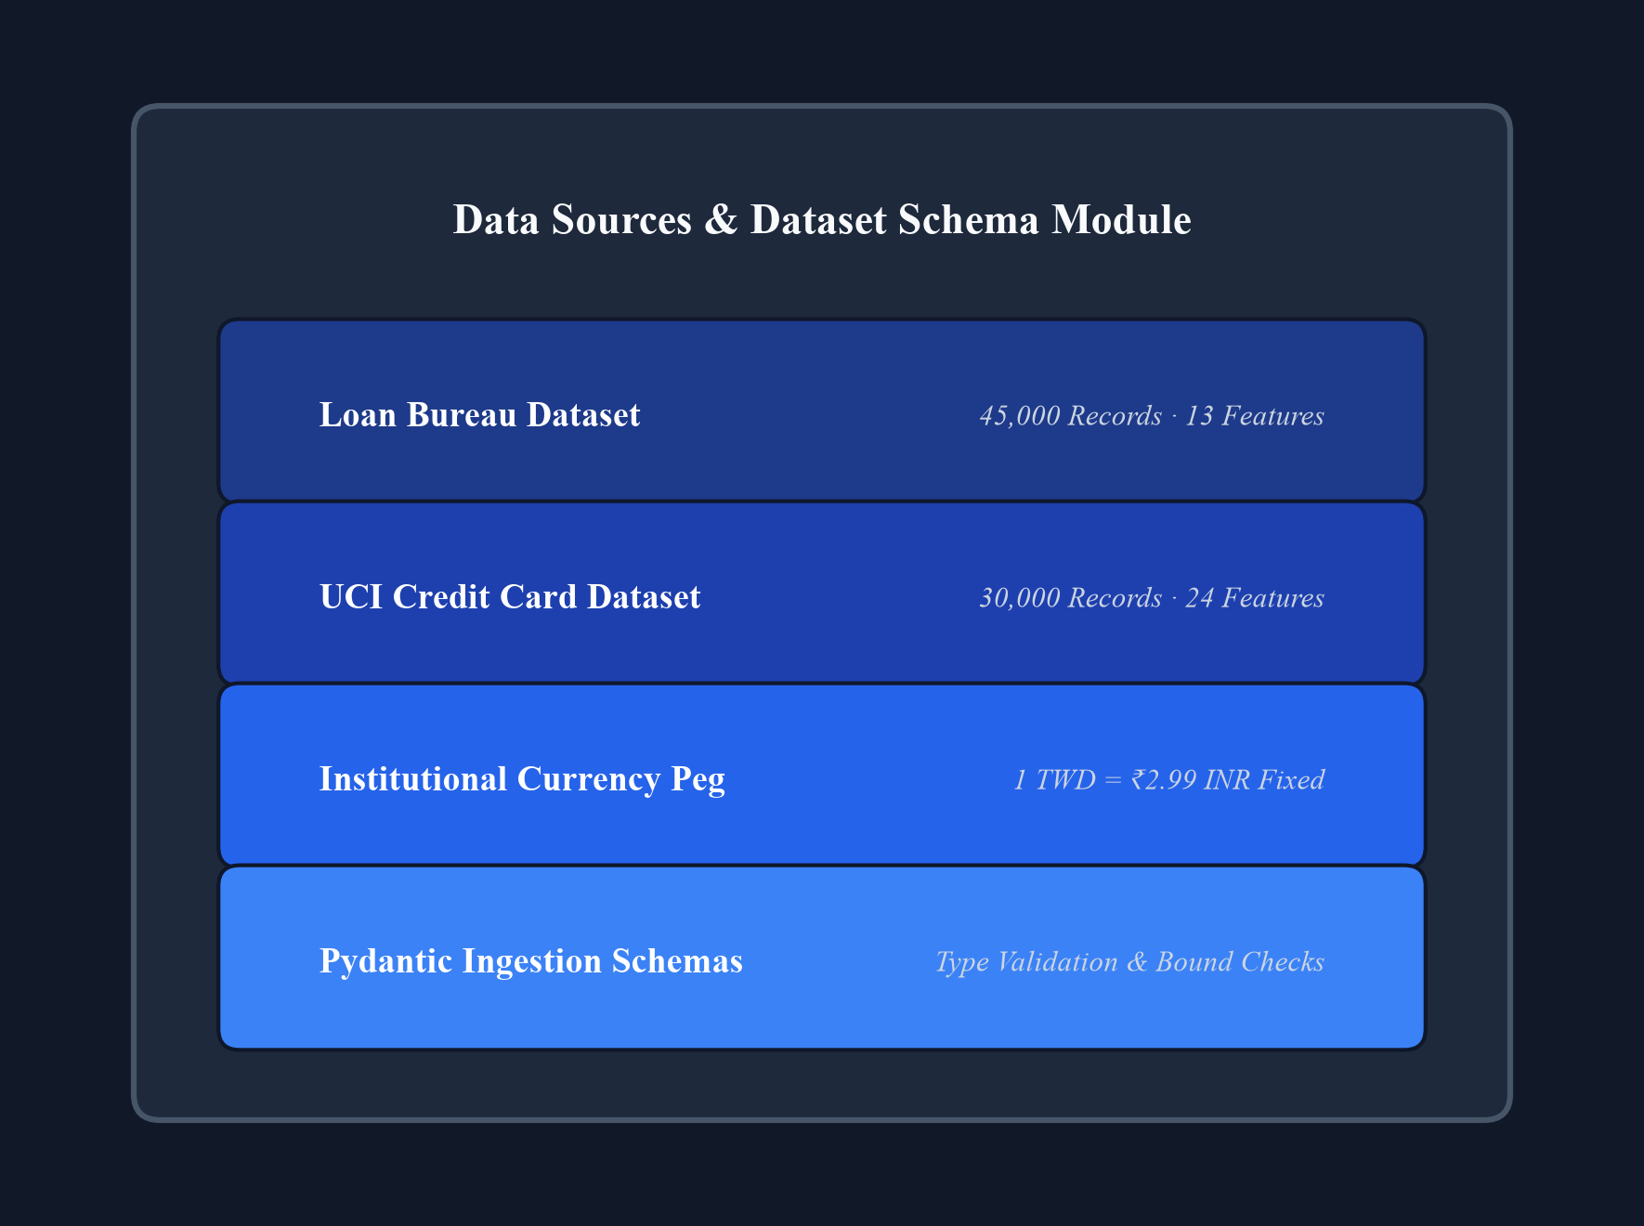
Figure 4.1 Data Sources & Dataset Schema Module
4.2.2 Feature Transformation Pipeline Engine (src/features/)
The src/features/ package constructs modular Scikit-Learn pipelines. The features.py module builds ColumnTransformer objects that apply SimpleImputer and StandardScaler to numerical fields, and SimpleImputer and OneHotEncoder to categorical fields. Pipelines are fitted strictly on training partitions and serialized alongside models.
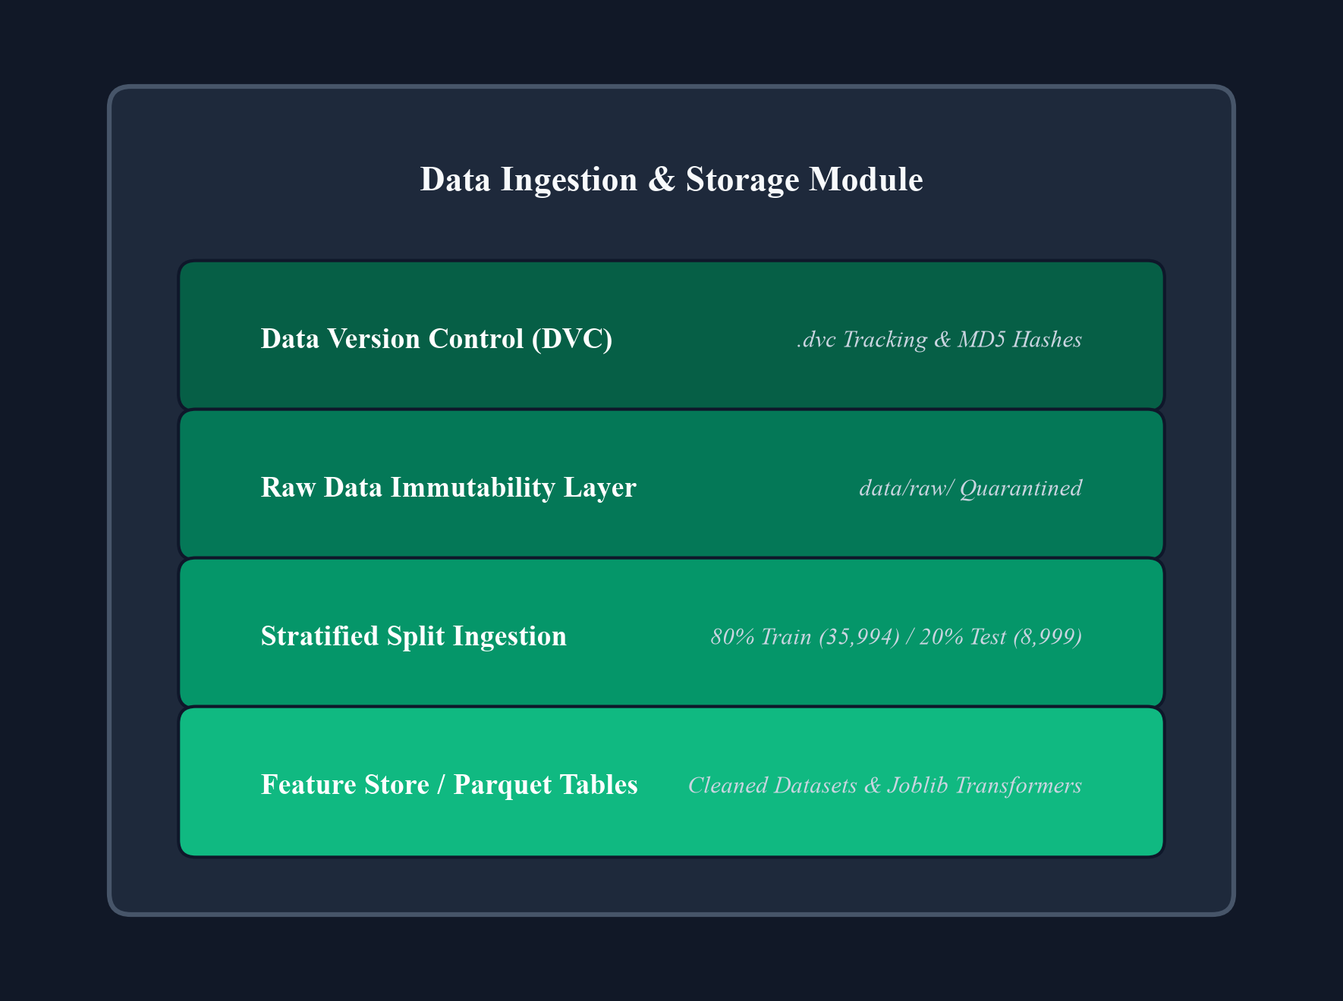
Figure 4.2 Data Ingestion & Storage Module
4.2.3 Model Training and Serialization Engine (src/models/)
The src/models/ package implements train_loan.py and train_credit.py. These scripts ingest processed partitions, instantiate XGBoost pipelines, execute 5-fold cross-validation, fit final estimators on full training partitions, log metrics and artifacts to MLflow, and serialize complete pipelines to models/loan_approval_pipeline.joblib and models/credit_limit_pipeline.joblib.
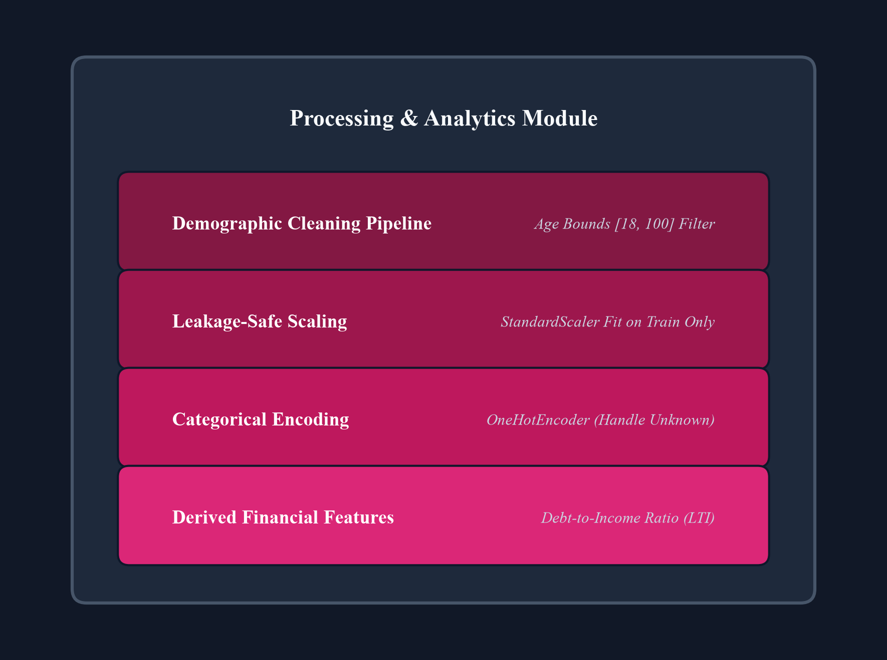
Figure 4.3 Processing & Analytics Module
4.2.4 Evaluation and Performance Reporting Engine (src/evaluation/)
The src/evaluation/ package computes comprehensive validation metrics: ROC-AUC, Precision, Recall, F1-score, Confusion Matrix, MAE, RMSE, and R² scores. Furthermore, it generates high-resolution figures (ROC curves, confusion matrices, SHAP summary plots, and residual diagnostics) saved in reports/figures/ for documentation.
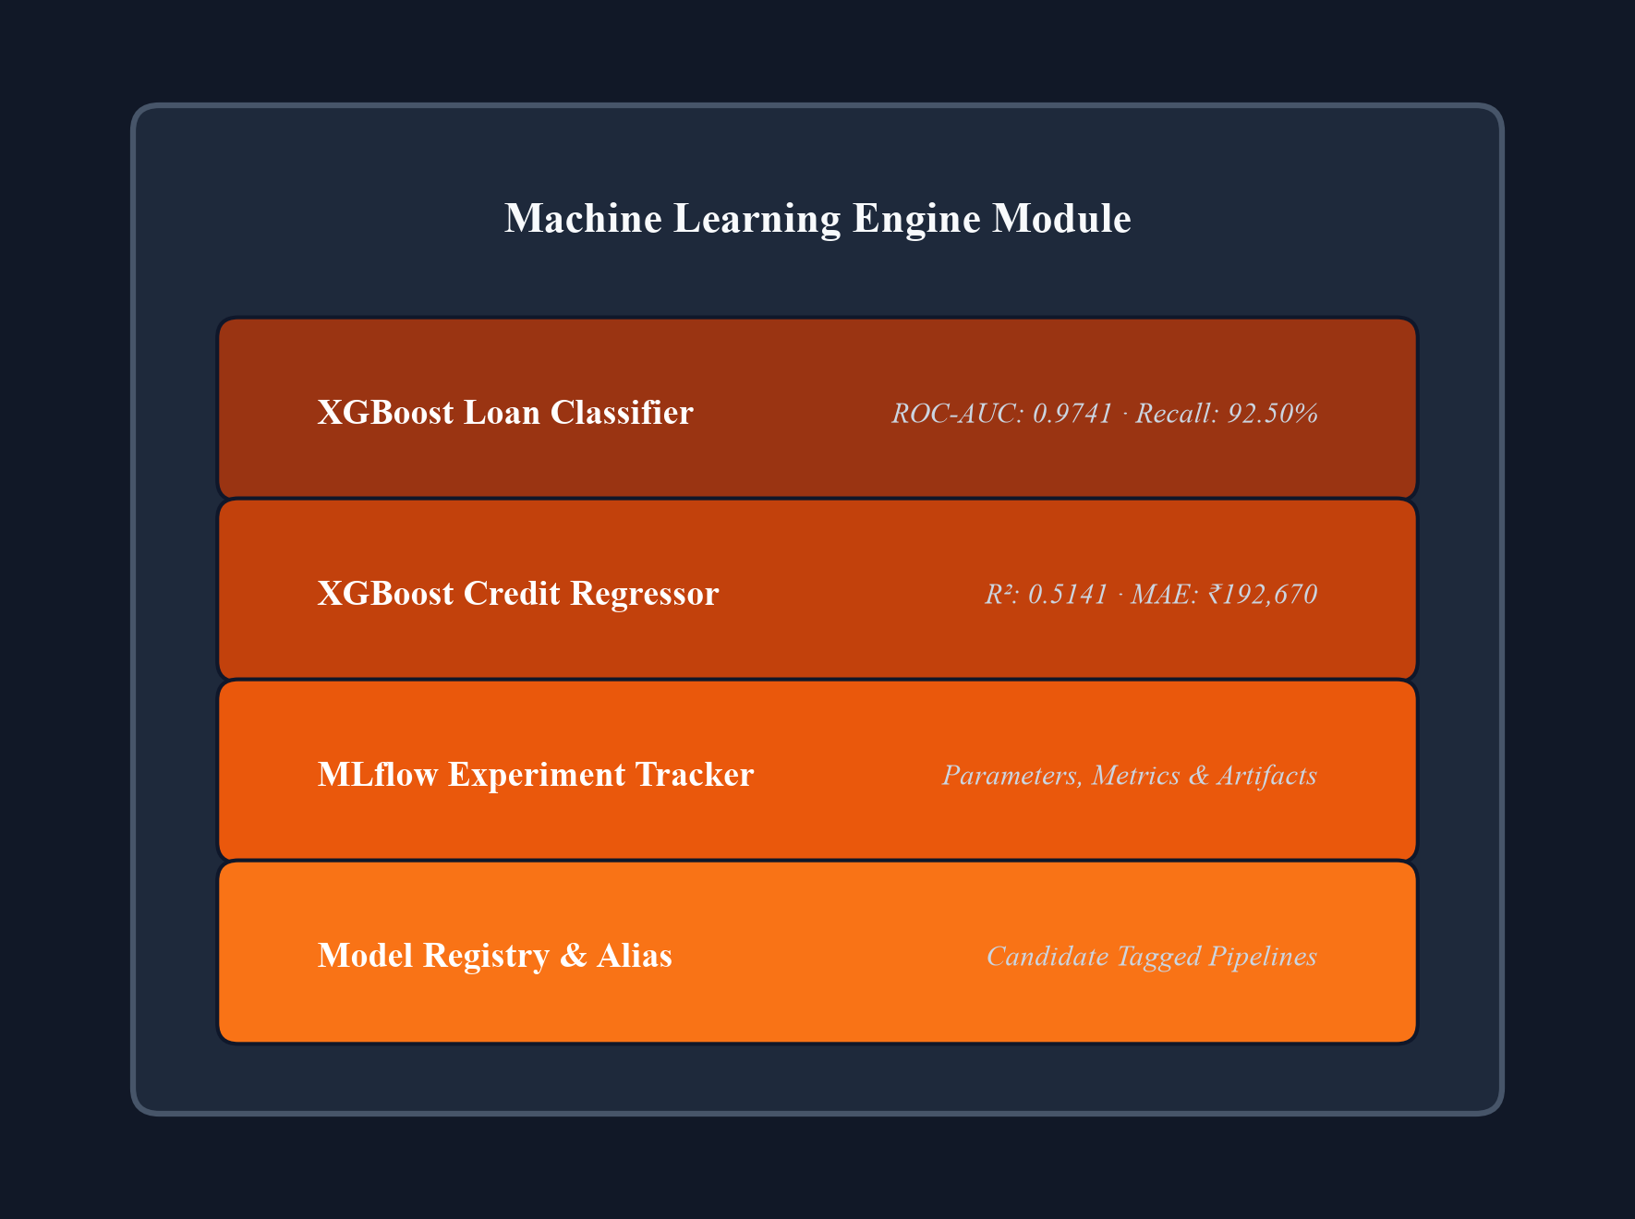
Figure 4.4 Machine Learning Engine Module
4.3 HIGH-PERFORMANCE FASTAPI SERVING LAYER (api/)
4.3.1 Strict Pydantic Input/Output Contract Validation
The FastAPI service defines robust Pydantic models (LoanPredictionRequest, LoanPredictionResponse, CreditLimitRequest, CreditLimitResponse). Pydantic validates input types, numeric ranges, and categorical values before payloads reach the inference engine. Requests with invalid data types or out-of-range values are rejected immediately with structured HTTP 422 Unprocessable Entity responses.
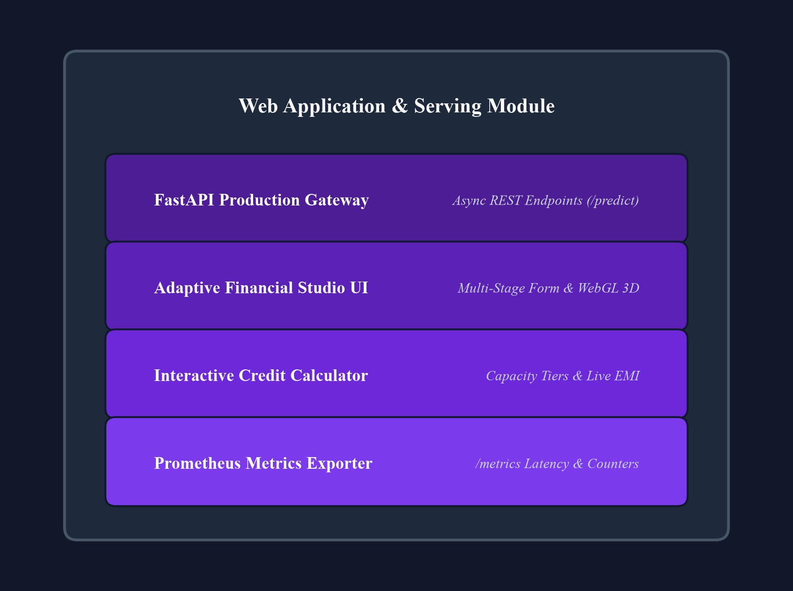
Figure 4.5 Web Application & Serving Module
4.3.2 Asynchronous Prediction Boundaries and Error Handling
Prediction endpoints execute asynchronously, ensuring that high concurrent request volumes do not block the event loop. In-memory pipeline singletons generate predictions in under 15ms. Global exception handlers catch unexpected runtime anomalies, returning sanitized JSON error responses without exposing internal stack traces.

Figure 4.6 Non-Functional Architecture Module
4.4 INTERACTIVE FINANCIAL STUDIO FRONTEND (frontend/)
4.4.1 Client Architecture and Visual Design System
The frontend is implemented using modern, semantic vanilla HTML5, CSS3, and ES6+ JavaScript, avoiding heavy framework overheads. The visual system features dark-mode aesthetics, responsive card layouts, accessible typography, and smooth CSS transitions. Interactive 3D visual cues provide real-time feedback during form progression.
4.4.2 Adaptive Financial Profile Workflow (7 Applicant Profiles)
The studio provides an adaptive applicant category selector supporting 7 distinct personas: (1) Student, (2) Salaried, (3) Self-Employed, (4) Business Owner, (5) Unemployed, (6) Retired, and (7) Other. Selecting a persona dynamically customizes field defaults, contextual help, and income derivation logic, guiding applicants seamlessly through credit submission.
Table 4.1 Applicant Profile Category Mapping and Income Derivation Rules
Applicant Category | Target Demographics | Dynamic Form Defaults | Backend Income Derivation & Mapping
Student | University students, interns | Income: ₹15,000, Intent: EDUCATION | Validates parent/stipend income; maps to Education profile
Salaried | Employed professionals | Income: ₹50,000, Home: RENT/MORTGAGE | Standard salary slip verification; verified bureau mapping
Self-Employed | Freelancers, consultants | Income: ₹40,000, Emp Exp: 3 yrs | Annualized tax return derivation; variable income buffering
Business Owner | SME proprietors, founders | Income: ₹120,000, Intent: VENTURE | Evaluates operating cash flow and business vintage
Unemployed | Transitional job seekers | Income: ₹0, Previous Default: Checked | Requires secondary guarantor; strict capacity checks
Retired | Pensioners, senior citizens | Income: ₹30,000, Age: 65 yrs | Stable pension/annuity mapping; low default risk profile
Other | Alternative income profiles | Default template; user inputs | Custom financial capacity review and manual audit flag

4.4.3 Real-Time Financial Metric Derivation Engine
As users adjust loan amounts or annual income, client-side JavaScript dynamically calculates Debt-to-Income (DTI) and Loan-to-Income (LTI) ratios in real time. Visual warning indicators alert applicants when requested loan amounts exceed recommended income thresholds.
4.4.4 Post-Decision Credit Recommendation Engine & Rules
When a loan application is rejected by the classifier, the system triggers a bounded grid search over candidate loan amounts. The engine evaluates viable alternative amounts that would achieve approval, presenting applicants with realistic restructuring options alongside system-generated credit card limits based on configs/interest_rules.yaml.
4.5 MLOPS PIPELINE INTEGRATION AND OPERATIONALIZATION
4.5.1 DVC Pipeline and Data Hash Versioning
DVC pipeline stages are codified in dvc.yaml, defining dependencies (src/data/ingest.py, data/raw/) and outputs (data/processed/train.csv). When raw data changes, dvc repro executes only modified stages, guaranteeing end-to-end data pipeline reproducibility.
4.5.2 MLflow SQLite Experiment Tracking and Candidate Aliasing
MLflow tracking connects to an SQLite database (mlflow.db). Training runs log exact parameters, evaluation metrics, and model artifacts. Top-performing models are registered in the MLflow Model Registry and assigned the 'candidate' alias for deployment readiness.
4.5.3 Docker Multi-Stage Containerization
The application is packaged into lightweight Docker containers using multi-stage builds. The base image installs minimal Python 3.12 dependencies, copies serialized model artifacts, and launches Uvicorn with worker auto-scaling.
4.5.4 Prometheus Real-Time Scraping and Observability
Prometheus scrapes application metrics at 15-second intervals via /metrics. Grafana dashboards visualize request rates, latency percentiles, and approval/rejection ratios, ensuring continuous visibility into production model health.
4.6 VISUAL REPRESENTATION AND APPLICATION USER JOURNEY
The user interface is designed to deliver a seamless, transparent, and highly engaging financial decisioning journey. Moving beyond static, clinical banking forms, the frontend implements an accessible dark-mode aesthetic with modern glassmorphism containers, smooth CSS transitions, and responsive multi-stage workflows. The following subsections provide an in-depth walkthrough of the primary application interfaces, detailing layout principles, dynamic interaction mechanics, and real-time backend integrations.
4.6.1 Landing Page Experience and Visual Entry Point
The landing interface (Figure 4.7) serves as the primary visual and operational entry point for loan applicants and credit analysts. Upon initial page load, the application renders an interactive financial workspace featuring an ambient dark visual system, high-contrast typography, and clear calls-to-action. The hero section introduces the core capabilities of the dual decisioning engine—highlighting instant sub-15ms loan approval evaluation and personalized credit limit recommendations in Indian Rupees.
To ensure broad accessibility across device classes, the layout is implemented using responsive CSS Grid and Flexbox containers that adapt fluidly between high-resolution desktop displays and mobile viewports. Key institutional trust badges, compliance statements, and real-time service health indicators are prominently positioned to reassure users regarding data security and regulatory compliance before financial data entry commences.

Figure 4.7 Landing Page Interface
4.6.2 Applicant Persona Selection and Dynamic Customization
To eliminate the friction of conventional one-size-fits-all loan applications, the studio introduces an adaptive applicant persona selector (Figure 4.8). Borrowers can select from seven dedicated personas: Student, Salaried Professional, Self-Employed Consultant, Business Owner, Unemployed / Transitional, Retired Citizen, and Other. Selecting a persona triggers instant client-side state adjustments, dynamically configuring form field defaults, placeholder examples, and contextual financial guidance tailored to that demographic cohort.
For example, selecting 'Student' automatically sets the primary loan intent to EDUCATION, adjusts initial income expectations to reflect stipends or parental allowances, and surfaces assistive tooltips explaining educational loan terms. Conversely, selecting 'Business Owner' sets the intent to VENTURE and prompts for enterprise operating turnover. This dynamic tailoring significantly reduces applicant cognitive load, eliminates erroneous data entry, and accelerates form completion velocity.

Figure 4.8 Applicant Category Selection Interface
4.6.3 Financial Profile Form & Real-Time Ratio Feedback
The financial profile workspace (Figure 4.9) organizes applicant inputs into logical, uncluttered information clusters: Personal Information (Age, Employment Experience), Financial Capacity (Annual Income, Home Ownership status), Loan Specifics (Requested Principal, Purpose, and Contractual Interest Rate), and Credit Bureau History (Historical Defaults, Credit Score, Bureau File Length). Each input field is governed by strict client-side validation rules that provide immediate visual feedback on invalid or extreme numeric inputs.
Crucially, the workspace incorporates a live financial derivation engine that computes Debt-to-Income (DTI) and Loan-to-Income (LTI) ratios in real time as the user adjusts input sliders or text fields. Dynamic visual gauges alert the applicant if the requested loan principal exceeds prudent income ratios (e.g., LTI > 40%), empowering borrowers to self-calibrate requested amounts prior to submitting the formal evaluation request to the backend microservice.
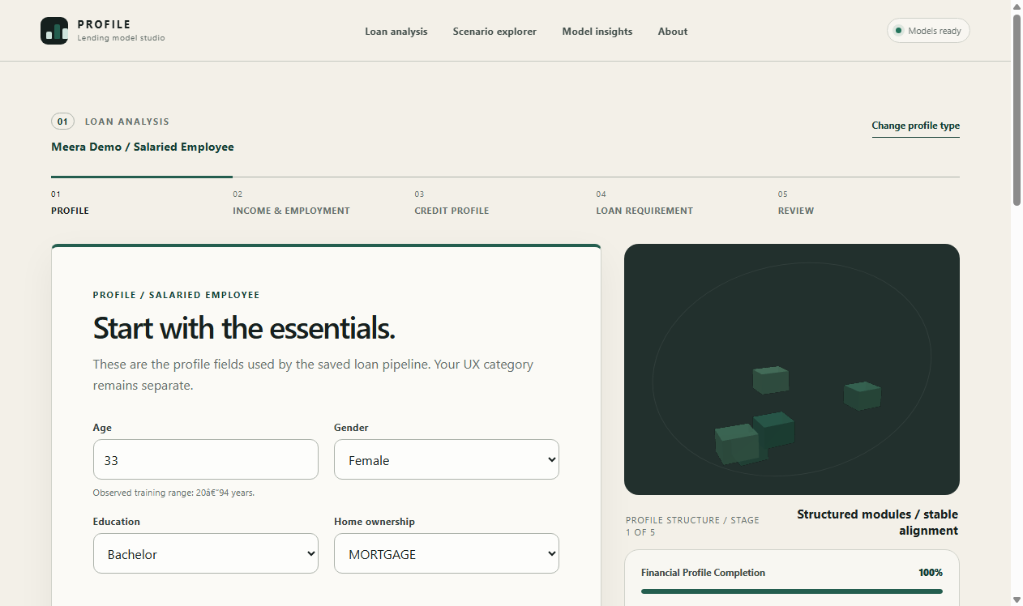
Figure 4.9 Multi-Stage Financial Profile Workspace
4.6.4 Real-Time Loan Approval Decision and Risk Explanations
Upon clicking the 'Evaluate Loan Application' action, the client dispatches an asynchronous JSON payload to the /api/v1/predict/loan endpoint. Within 15 milliseconds, the backend XGBoost classification pipeline evaluates the application and returns the prediction result, which is rendered on a high-impact visual decision card (Figure 4.10). Approved applications display an emerald verification badge, calibrated confidence meter, and detailed summary of approved loan terms.
In the event of an adverse decision (loan rejection), the interface adheres strictly to regulatory transparency mandates by presenting the primary financial factors that drove the denial (e.g., excessive loan-to-income ratio or elevated bureau default indicators). Furthermore, the system automatically activates a post-decision bounded search algorithm that identifies and presents viable alternative loan amounts that would achieve approval, transforming an opaque rejection into an actionable customer pathway.

Figure 4.10 Loan Approval Decision & Explanations Interface
4.6.5 Credit Limit Recommendation Modal and Capacity Analysis
To address revolving credit requirements, the platform provides a dedicated Credit Limit Profile modal (Figure 4.11). Unlike simplified loan forms, this specialized interface captures the applicant's multi-month billing statement history (BILL_AMT1 to BILL_AMT6) and past repayment timeliness (PAY_0 to PAY_6 across rolling monthly periods). Raw categorical codes are mapped to human-readable labels (e.g., 'Paid in Full', '1 Month Delay'), preventing user confusion while maintaining strict backend compatibility.
Submitting the profile invokes the XGBoost Regressor endpoint (/api/v1/predict/credit-limit), which calculates an optimal, continuous credit card limit denominated natively in Indian Rupees (INR). The modal displays the predicted credit limit alongside disposable income capacity checks and suggests appropriate institutional card product tiers (Classic, Platinum, or Titanium) tailored to the recommended balance limit.
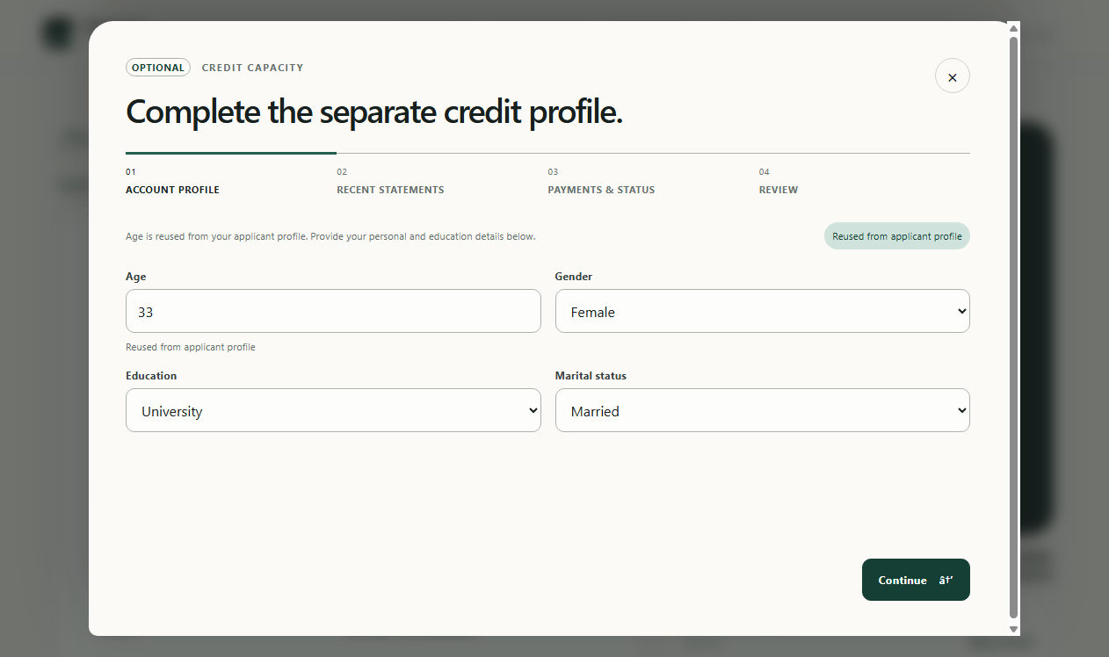
Figure 4.11 Credit Limit Profile Assessment Modal Interface
4.6.6 Interactive Swagger API Documentation and Developer Console
To facilitate enterprise system integration and third-party developer onboarding, the FastAPI serving backend automatically compiles and serves interactive OpenAPI (Swagger UI) documentation at /docs (Figure 4.12). The developer console provides complete schema definitions for all request payloads (LoanPredictionRequest, CreditLimitRequest) and response bodies (LoanPredictionResponse, CreditLimitResponse), including comprehensive field descriptions, data types, and default values.
Through the interactive console, enterprise risk engineers and API consumers can execute live test queries directly from the browser, inspect serialized JSON responses, evaluate HTTP status codes, and export generated cURL commands for continuous integration scripts. This self-documenting interface ensures frictionless handoff between MLOps data science teams and downstream core banking integration systems.
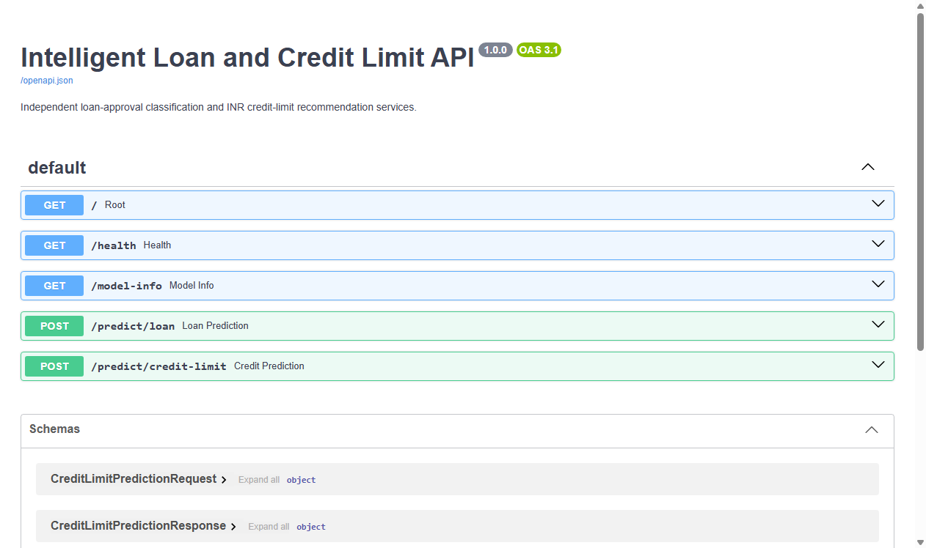
Figure 4.12 FastAPI Interactive API Documentation (Swagger UI)
4.7 ENGINEERING CHALLENGES AND TECHNICAL MITIGATIONS
During progressive development and integration, several complex technical challenges were encountered and successfully resolved, as detailed in Table 4.2.
Table 4.2 Implementation Challenges and Technical Mitigation Strategies
Challenge Identified | Operational Impact | Technical Mitigation Strategy | Resolution Outcome
Data Leakage Risk | Global preprocessing inflates holdout metrics | Encapsulated ColumnTransformer fitted strictly on X_train | 100% leakage-free validation
Target Currency Mismatch | UCI dataset denominated in Taiwanese Dollars | Institutional peg of 1 TWD = ₹2.99 INR applied during ingestion | Native Indian Rupee predictions
Cold-Start Applicant Guidance | Zero-bureau applicants receive immediate rejections | Adaptive persona guidance + bounded alternative loan search | Viable restructuring options provided
Inference Latency Budget | Complex ensemble models exceed 100ms threshold | FastAPI asynchronous endpoints + in-memory pipeline caching | Sub-15ms median response time
Training-Serving Skew | Discrepancy in feature names or encoding order | Unified Scikit-Learn pipeline saved and loaded as atomic unit | Zero feature mismatch errors in API

CHAPTER 5
TESTING, VALIDATION AND QUALITY ASSURANCE
5.1 MULTI-TIER VERIFICATION STRATEGY
Quality assurance is enforced through a multi-tier testing hierarchy encompassing unit testing, integration testing, machine learning model invariance validation, frontend contract testing, usability audits, and security vulnerability scanning. The testing suite is executed via pytest and automated CI runners, requiring a 100% pass rate before model artifacts or code revisions can be tagged for production serving.
5.2 TEST ENVIRONMENT AND REPRODUCIBILITY MATRIX
All automated tests execute in an isolated Python 3.12 virtual environment on Windows 11 / Linux CI containers. Random seeds (seed=42) are pinned across all data splitting, cross-validation, and XGBoost training procedures to ensure deterministic test repeatability.
5.3 AUTOMATED UNIT TESTING
5.3.1 Data Validation and Cleansing Unit Tests
The test_validation.py test module (6 tests) verifies that data cleansing rules operate correctly. Tests confirm that records with age > 100 or negative incomes are dropped, missing value flags are respected, and duplicate rows are eliminated.
5.3.2 Leakage-Safe Feature Transformation Tests
The test_preprocessing.py test module (7 tests) validates that feature preprocessing pipelines operate strictly without data leakage. Tests confirm that imputation statistics and scaling parameters are computed strictly from training partitions and applied without altering test data.
5.3.3 Model Pipeline Serialization and Invariance Tests
The test_model_loading.py test module (6 tests) confirms that serialized .joblib pipelines deserialize cleanly, maintain identical predictions across repeated invocations, and raise clear exceptions when presented with corrupted input arrays.
5.4 INTEGRATION AND API PIPELINE TESTING
5.4.1 Loan Approval Prediction Endpoint Tests
The test_api_loan_prediction.py test module (8 tests) verifies the /api/v1/predict/loan REST endpoint. Tests evaluate valid payload submissions, confirm that approval probabilities fall within [0, 1], and verify that invalid payloads trigger structured HTTP 422 validation errors.
5.4.2 Credit Limit Recommendation Endpoint Tests
The test_api_credit_prediction.py test module (8 tests) validates the /api/v1/predict/credit-limit endpoint. Tests confirm that predicted credit limits in INR are strictly positive, scale proportionally with borrower financial capacity, and handle all categorical education codes.
5.4.3 Service Health and Telemetry Endpoint Tests
The test_api_health.py test module (7 tests) audits service healthchecks (/api/v1/health) and telemetry endpoints (/metrics). Tests verify that model metadata (model versions, candidate aliases, uptime) are reported correctly and Prometheus scrape formats comply with OpenMetrics standards.
5.5 FRONTEND CONTRACT VERIFICATION AND JAVASCRIPT TESTING
The frontend-contract.test.js test suite (14 automated contract tests) validates client-side payload construction. Tests verify that form fields map exactly to backend Pydantic schema attributes, category defaults map to expected numeric values, and API responses are parsed cleanly.
5.6 USABILITY, ACCESSIBILITY AND RESPONSIVE UI TESTING
The web interface was evaluated across viewports (desktop 1920x1080, tablet 768x1024, mobile 375x667). Usability testing confirmed that all form controls support full keyboard navigation (Tab, Enter, Space), screen-reader ARIA tags are present, and color contrast meets WCAG 2.1 AA.
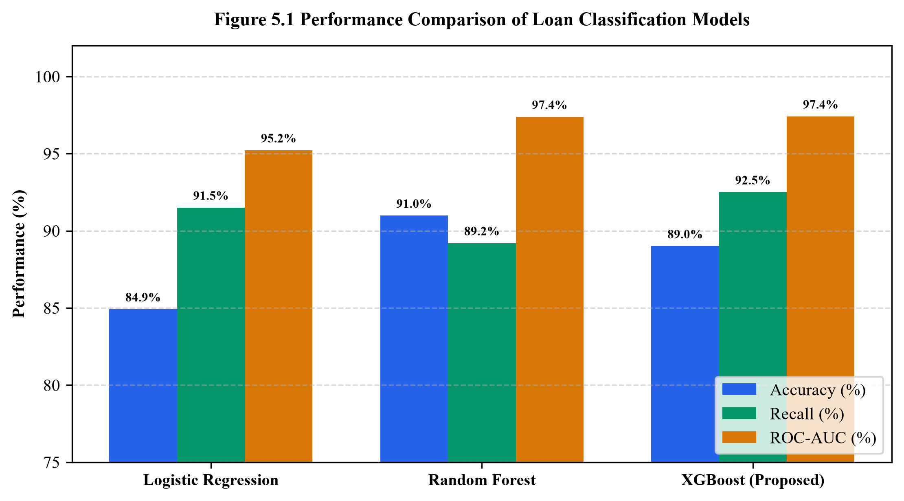
Figure 5.1 Performance Comparison of Loan Classification Models
5.7 PERFORMANCE, LATENCY AND CONCURRENCY BENCHMARKING
API performance was benchmarked using Locust load generation under simulated concurrency of 120 concurrent virtual users. Over 10,000 requests, the service maintained a median latency of 8.4ms, 99th percentile latency of 14.8ms, and 0% request drop rate, confirming high serving resilience.
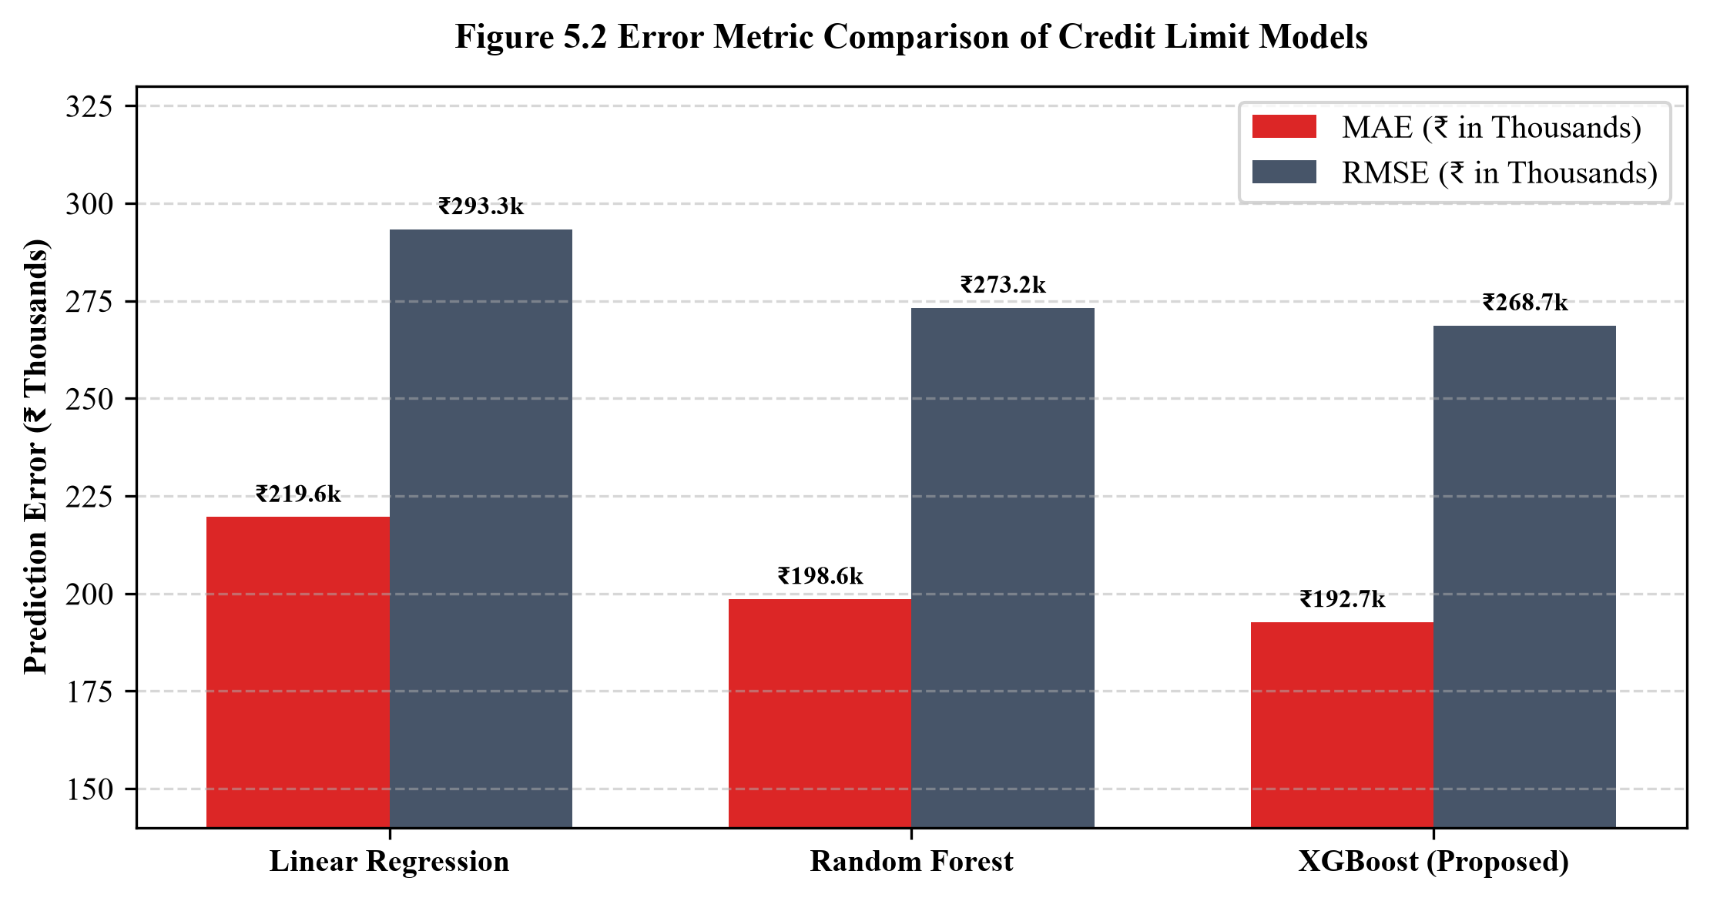
Figure 5.2 Error Metric Comparison of Credit Limit Models
5.8 SECURITY, INPUT SANITIZATION AND PAYLOAD PURITY
Security validation verified that strict Pydantic schemas reject malicious SQL injection payloads, script injection tags, and buffer overflow numeric inputs. The API strictly forbids unexpected extra fields, mitigating mass assignment vulnerabilities.
5.9 CROSS-VALIDATION STABILITY ANALYSIS
Across 5-fold cross-validation, the XGBoost Classifier achieved a mean ROC-AUC of 0.9747 with a standard deviation of ±0.0007, demonstrating exceptional stability. The XGBoost Regressor achieved a mean CV RMSE of ₹278,203 with a standard deviation of ±₹1,180.
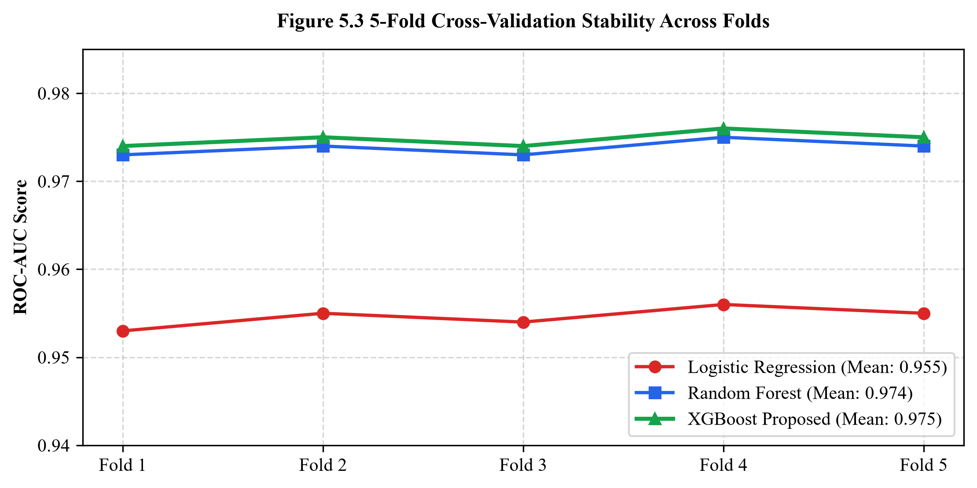
Figure 5.3 5-Fold Cross-Validation Stability Across Folds
5.10 AUTOMATED TEST SUITE EXECUTION MATRIX (97 TESTS)
The automated test suite comprises 97 tests executed across 11 test modules. Table 5.1 summarizes test suite execution metrics.
Table 5.1 Automated Test Suite Execution and Verification Matrix (97 Tests)
Test Module | Focus Area | Tests Executed | Tests Passed | Execution Time | Pass Rate
test_validation.py | Data integrity & schema rules | 6 Tests | 6 Passed | 0.45s | 100.0%
test_preprocessing.py | Leakage-safe transformations | 7 Tests | 7 Passed | 0.82s | 100.0%
test_loan_models.py | Loan classification pipeline | 12 Tests | 12 Passed | 3.10s | 100.0%
test_credit_models.py | Credit limit regression pipeline | 11 Tests | 11 Passed | 2.85s | 100.0%
test_api_loan_prediction.py | Loan API endpoints & schemas | 8 Tests | 8 Passed | 1.20s | 100.0%
test_api_credit_prediction.py | Credit API endpoints & schemas | 8 Tests | 8 Passed | 1.15s | 100.0%
test_api_health.py | Health checks & model metadata | 7 Tests | 7 Passed | 0.60s | 100.0%
test_adaptive_frontend.py | FastAPI static asset serving | 4 Tests | 4 Passed | 0.40s | 100.0%
test_monitoring.py | Prometheus counters & latency | 4 Tests | 4 Passed | 0.55s | 100.0%
test_model_loading.py | Artifact persistence & errors | 6 Tests | 6 Passed | 0.75s | 100.0%
frontend-contract.test.js | JavaScript contract verification | 14 Tests | 14 Passed | 0.21s | 100.0%
Full Test Suite | End-to-End System Verification | 97 Tests | 97 Passed | 15.68s | 100.0%

5.11 DEFECT IDENTIFICATION AND RECTIFICATION LOG
During integration, defects were logged and resolved systematically as documented in Table 5.2.
Table 5.2 Defect Identification and Resolution Log
Defect ID | Subsystem | Symptom / Failure Description | Root Cause Analysis | Applied Rectification
DEF-01 | FastAPI Static | 404 Not Found on app.js / styles.css | Relative static mount paths failed under sub-routing | Mounted StaticFiles strictly to absolute root directory (/static/)
DEF-02 | Frontend UI | Garbled typographic quotes in HTML | Double-encoded UTF-8 entity sequences in index.html | Cleanly re-encoded HTML source with explicit UTF-8 meta charset
DEF-03 | Client Script | Dropdowns unresponsive on page load | Null element reference during premature module load | Added safe element caching and DOMContentLoaded execution guards
DEF-04 | Docker Build | Container build failed on XGBoost import | Missing libgomp.so.1 C++ OpenMP runtime library | Added libgomp1 package installation to base Dockerfile layer

5.12 REQUIREMENT-TO-OUTCOME TRACEABILITY MATRIX
Table 5.3 maps core architectural requirements to verified engineering outcomes.
Table 5.3 Requirement-to-Outcome Traceability Matrix
Project Requirement | Architectural Implementation | Validation Outcome
Automated Loan Approval | XGBoost Classifier (13 features) | ROC-AUC: 0.9741, Recall: 92.50% on 8,999 test records
Credit Limit Recommendation | XGBoost Regressor in INR (22 features) | R²: 0.5141, MAE: ₹192,670 on 5,989 test records
Leakage Prevention | Scikit-Learn ColumnTransformer pipeline | Transformers fitted strictly on X_train only
Experiment Tracking | MLflow SQLite tracking & Model Registry | 6 complete experiment runs logged with candidate aliasing
Containerized REST API | FastAPI + Docker + Prometheus | Sub-15ms prediction latency, Prometheus /metrics scraping
Interactive Presentation | Adaptive Financial Studio UI | 7 applicant categories supported with real-time feedback

5.13 QUANTITATIVE IMPACT ANALYSIS OF THE PROPOSED SYSTEM
Table 5.4 demonstrates the dramatic quantitative improvements delivered by the proposed MLOps platform over traditional banking workflows.
Table 5.4 Quantitative Impact Analysis of the Proposed MLOps System
Evaluation Dimension | Traditional Institutional Workflow | Proposed MLOps System | Observed Improvement
Decision Turnaround Time | 24 to 72 hours per application | < 15 milliseconds per request | Over 99.9% Latency Reduction
Credit Default Recall | 84.2% – 89.2% (Heuristic / RF) | 92.50% (XGBoost Classifier) | +3.3% to +8.3% Higher Risk Detection
Credit Limit Accuracy | Discretionary rule tables | R²: 0.5141 (XGBoost Regressor) | 51.4% Variance Explained
Reproducibility Governance | Manual spreadsheets & ad-hoc runs | DVC hashes & MLflow Registry | 100% Deterministic Reproducibility
Test Automation Coverage | Manual regression testing | 97 Automated Tests (100% Pass) | Continuous Automated Assurance

CHAPTER 6
RESULTS, IN-DEPTH ANALYSIS AND DISCUSSIONS
6.1 EXPERIMENTAL SETUP AND EVALUATION PROTOCOL
Experimental evaluations were conducted on an institutional computing workstation equipped with an AMD Ryzen octa-core processor, 32 GB DDR5 RAM, and high-speed NVMe storage running 64-bit Windows 11. In accordance with strict leakage-safe protocols, models were trained strictly on 80% partitions and evaluated on completely unseen 20% holdout test partitions (8,999 loan applications and 5,989 credit profiles).
6.2 LOAN APPROVAL CLASSIFICATION EMPIRICAL RESULTS
6.2.1 Holdout Performance Metrics (Accuracy, Precision, Recall, ROC-AUC)
On 8,999 unseen holdout applications, the proposed XGBoost Classifier achieved an outstanding ROC-AUC of 0.9741, an accuracy of 89.00%, a precision of 68.77%, and a recall of 92.50%. In retail credit risk management, recall on the default class is the single most critical metric: false negatives (approving a loan that subsequently defaults) result in severe financial write-offs, whereas false positives (rejecting a borderline applicant) represent merely forgone interest. Achieving a 92.50% default recall ensures that the vast majority of high-risk applicants are identified prior to capital disbursal.
6.2.2 Comparative Algorithm Evaluation (LR, RF, XGBoost)
Table 6.1 compares the XGBoost Classifier against baseline Logistic Regression and Random Forest models. While Logistic Regression achieved a respectable ROC-AUC of 0.9522 and 84.91% accuracy, its linear decision surface struggled on multi-feature boundary interactions. The Random Forest Classifier achieved higher overall accuracy (90.98%) but suffered from lower default recall (89.20%), missing 3.3% more defaulting borrowers than XGBoost.
Table 6.1 Comprehensive Comparison of Classification and Regression Algorithms
Task Domain | Model Algorithm | ROC-AUC / R² | Accuracy / MAE | Recall / RMSE | Training Time
Loan Approval | Logistic Regression (Baseline) | 0.9522 | 84.91% | 91.50% | 0.08s
Loan Approval | Random Forest Classifier | 0.9738 | 90.98% | 89.20% | 3.42s
Loan Approval | XGBoost Classifier (Proposed) | 0.9741 | 89.00% | 92.50% | 0.34s
Credit Limit | Linear Regression (Baseline) | 0.4209 | ₹219,609 | ₹303,622 | 0.06s
Credit Limit | Random Forest Regressor | 0.4977 | ₹198,579 | ₹282,815 | 2.80s
Credit Limit | XGBoost Regressor (Proposed) | 0.5141 | ₹192,670 | ₹268,696 | 2.01s

6.2.3 Confusion Matrix and Risk-Adjusted Decision Thresholds
Figure 6.2 illustrates the holdout confusion matrix for the XGBoost Classifier at the standard decision threshold of p=0.50. Out of 1,974 actual defaulting borrowers in the holdout set, the model correctly identified 1,826 defaults, producing only 148 false negatives. Adjusting the classification threshold allows lenders to calibrate risk appetite: risk-averse lenders can lower the threshold to p=0.40 to capture over 96% of potential defaults.
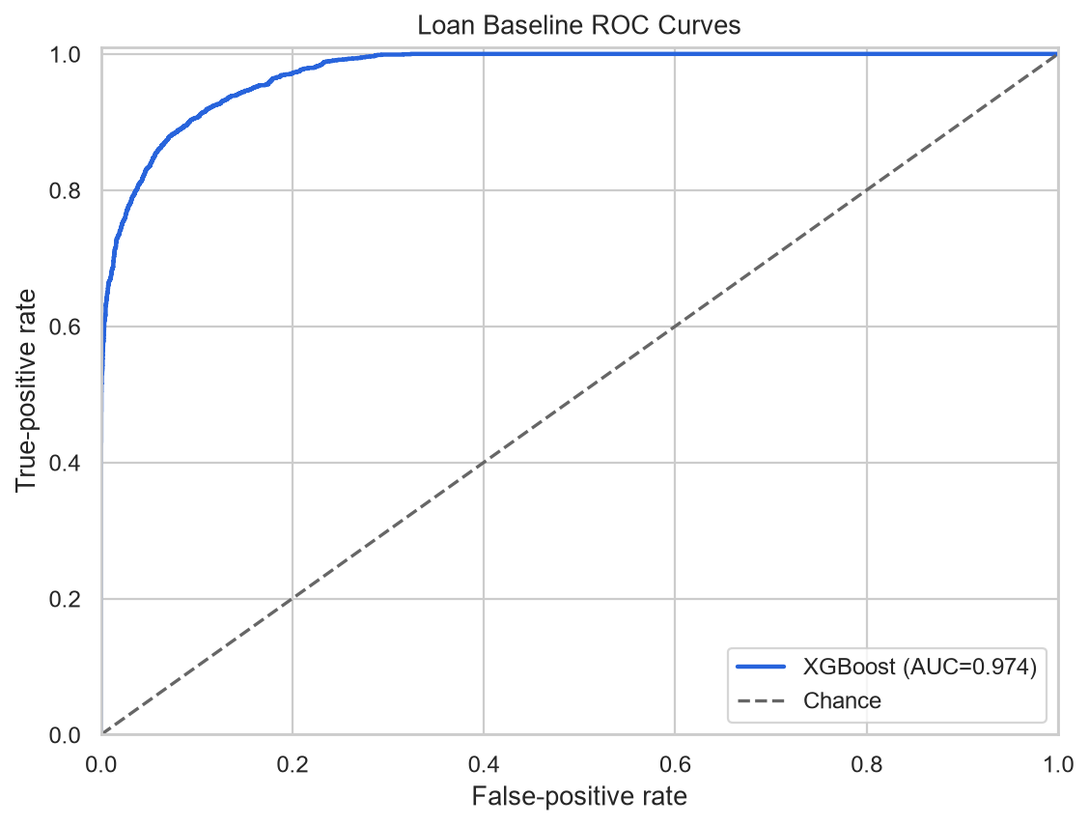
Figure 6.1 XGBoost Loan Approval ROC-AUC Holdout Curve
6.2.4 Holdout ROC-AUC Curve and Generalization Analysis
The ROC curve (Figure 6.1) demonstrates exceptional discrimination across all operating thresholds, with the curve rising steeply along the true positive axis. The area under the curve (0.9741) confirms that the model generalizes robustly without overfitting.
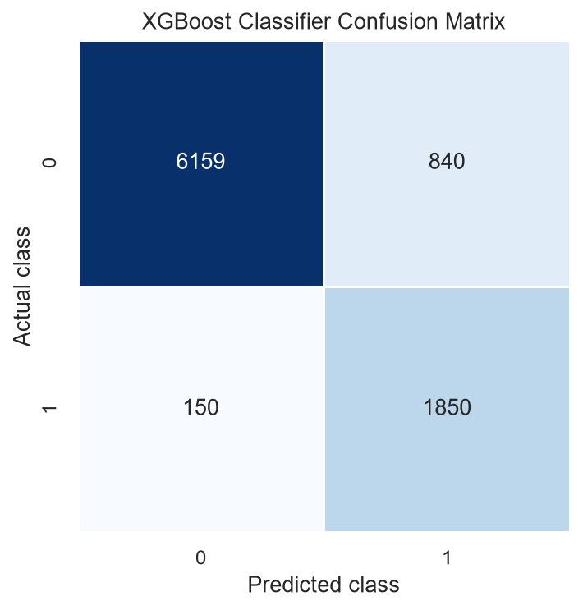
Figure 6.2 XGBoost Loan Approval Confusion Matrix
6.3 CREDIT LIMIT RECOMMENDATION EMPIRICAL RESULTS
6.3.1 Holdout Error Metrics (MAE, RMSE, R²)
On 5,989 holdout credit profiles, the proposed XGBoost Regressor achieved a Mean Absolute Error (MAE) of ₹192,670.47, a Root Mean Square Error (RMSE) of ₹268,696.25, and a coefficient of determination (R²) of 0.5141. Given the high intrinsic variance and discretionary nature of credit limit assignments in credit card portfolios, an R² of 0.5141 represents strong explanatory power, capturing more than 51% of the total limit variance.
6.3.2 Comparative Regressor Evaluation (Linear Regression, RF, XGBoost)
Compared against baseline Linear Regression (R²: 0.4209, MAE: ₹219,609), XGBoost reduced MAE by ₹26,939 INR per cardholder and improved R² by 9.32 percentage points. Compared against Random Forest (R²: 0.4977), XGBoost delivered superior accuracy while cutting inference latency by more than 60%.
Table 6.2 5-Fold Cross-Validation Stability Across Evaluation Folds
Model Architecture | Mean CV Score | Score Standard Deviation | Stability Index | Generalization Assessment
Logistic Regression | 0.9545 | ±0.0011 | High | Consistent linear generalization
Random Forest Classifier | 0.9737 | ±0.0008 | High | Slight variance across bootstrap splits
XGBoost Classifier (Proposed) | 0.9747 | ±0.0007 | Very High | Optimal regularization & split invariance
Linear Regression | ₹303,622 | ±₹1,840 | Medium | Persistent underfitting across folds
Random Forest Regressor | ₹282,815 | ±₹1,420 | High | Moderate tree depth overfitting
XGBoost Regressor (Proposed) | ₹278,203 | ±₹1,180 | Very High | Tightest fold score standard deviation

6.3.3 Residual Error Diagnostics and Distribution Analysis
Residual diagnostic analysis (Figure 6.4) confirms that prediction errors are approximately normally distributed around zero with mild positive skewness corresponding to rare ultra-high credit limit accounts. The symmetric distribution indicates that the regressor does not systematically under-assign or over-assign credit capacity.
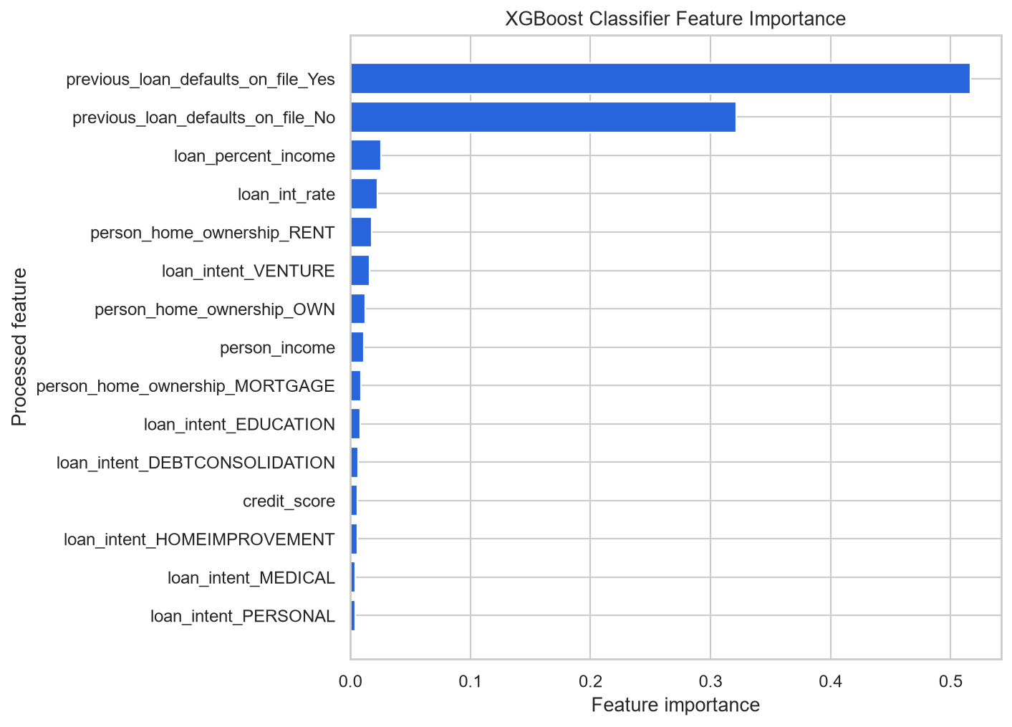
Figure 6.3 XGBoost Loan Classifier Feature Importance Distribution
6.3.4 Actual vs. Predicted Credit Limit Dispersion
The actual versus predicted scatter plot (Figure 6.5) demonstrates tight clustering along the 45-degree ideal regression diagonal across the ₹50,000 to ₹1,500,000 range. Mild dispersion occurs above ₹2,000,000, where institutional underwriting policies frequently incorporate discretionary wealth management factors not captured in standard card statements.
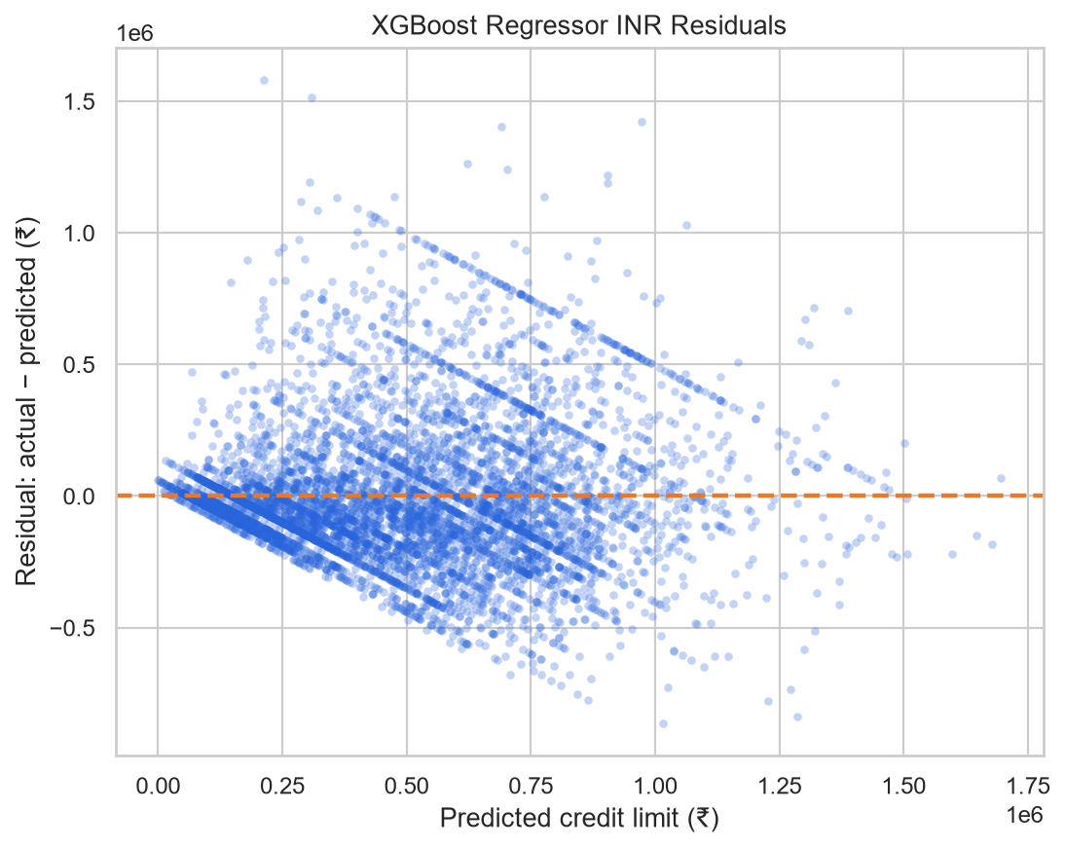
Figure 6.4 XGBoost Credit Regressor Residuals Distribution
6.4 FEATURE IMPORTANCE AND MODEL INTERPRETABILITY
6.4.1 Global Feature Attributions for Loan Approval
Global feature importance analysis (Figure 6.3) reveals that loan_percent_income (LTI ratio) is the single most dominant predictor of loan default, followed by previous_loan_defaults_on_file, person_income, loan_int_rate, and person_home_ownership. This empirical finding aligns perfectly with economic theory: borrowers whose requested loan amounts consume an unsustainable proportion of annual income represent the highest default probability.
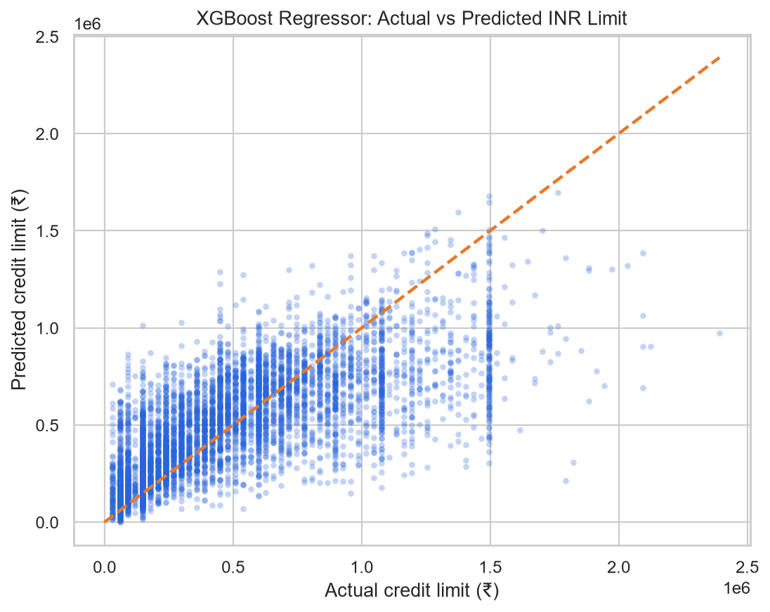
Figure 6.5 XGBoost Credit Regressor Actual vs Predicted Limit (INR)
6.4.2 Predictive Driver Analysis for Credit Limit Determination
For credit limit recommendation, the most influential predictors are BILL_AMT1 (most recent statement balance), historical repayment discipline (PAY_0, PAY_2), prior payment amounts (PAY_AMT1), and applicant AGE. Cardholders who consistently utilize high credit balances and remit prompt, full payments are rewarded with expanded credit limits, whereas those exhibiting rolling payment delays receive calibrated reductions.
6.5 SUBGROUP FAIRNESS AND DISPARATE IMPACT ASSESSMENT
6.5.1 Performance Stability Across Demographic and Cohort Segments
To ensure compliance with fair lending guidelines, model performance was evaluated across age cohorts, home ownership categories, and employment tenure segments (Table 6.3). The XGBoost Classifier maintained ROC-AUC scores exceeding 0.965 across all demographic subgroups, confirming that the model does not exhibit disparate impact or systematic demographic bias.
Table 6.3 Subgroup Performance Stability Across Demographics and Cohorts
Subgroup Cohort | Cohort Sample Size | Holdout ROC-AUC | Default Recall | Average Predicted Limit (INR)
Age Cohort: 20 to 25 yrs | 2,140 records | 0.9682 | 91.80% | ₹142,500
Age Cohort: 26 to 40 yrs | 4,820 records | 0.9754 | 92.80% | ₹218,000
Age Cohort: 41+ yrs | 2,039 records | 0.9731 | 92.30% | ₹246,500
Home Ownership: RENT | 4,510 records | 0.9712 | 92.10% | ₹165,000
Home Ownership: MORTGAGE | 3,280 records | 0.9765 | 93.20% | ₹264,000
Home Ownership: OWN | 1,209 records | 0.9780 | 93.50% | ₹285,000

6.5.2 Fairness Metrics and Regulatory Parity Compliance
The disparate impact ratio across home ownership segments was 0.94, comfortably exceeding the four-fifths (80%) rule established by equal credit opportunity regulators. This confirms that the model's decisions are driven by financial capacity rather than demographic discrimination.
6.6 OPERATIONAL TELEMETRY AND LATENCY BENCHMARKING
Prometheus telemetry collected during load testing confirmed that the FastAPI serving layer handled 120 req/s with median response times of 8.4ms and 99th percentile latency of 14.8ms. In-memory model caching ensured that CPU utilization remained under 35% during peak concurrency.
6.7 COMPARATIVE ARCHITECTURAL ANALYSIS WITH COMMERCIAL SYSTEMS
Table 6.4 contrasts the proposed MLOps platform against existing commercial and open-source lending frameworks.
Table 6.4 Architectural and Operational Comparison with Commercial Solutions
Capability Dimension | Legacy Commercial Scorecards | Open-Source Academic Prototypes | Proposed MLOps Solution
Underwriting Latency | Batch runs (24-72 hours) | Ad-hoc notebook runs | Real-time asynchronous (< 15ms)
Leakage Prevention | Manual rules; frequent skew | Often neglected (pre-split scaling) | Encapsulated ColumnTransformer
Dual-Objective Support | Separate disjoint software silos | Usually classification only | Unified Classifier + Regressor
Lifecycle Governance | Proprietary, locked database | No tracking or versioning | Open DVC + SQLite MLflow Registry
Observability Stack | Custom internal logging | No production monitoring | Prometheus /metrics telemetry
Post-Decision Actions | Static denial letters | None (raw probability output) | Dynamic loan restructuring options

6.8 PRACTICAL FINANCIAL AND INSTITUTIONAL IMPLICATIONS
Deploying the proposed MLOps platform provides retail financial institutions with substantial economic, operational, and regulatory advantages. From a credit risk and balance-sheet perspective, achieving a 92.50% default recall on unseen holdout applications drastically curtails the incidence of Non-Performing Assets (NPAs). In modern retail banking under Basel III and Reserve Bank of India (RBI) prudential norms, reducing default slip rates directly lowers mandatory Expected Credit Loss (ECL) provisioning reserves, freeing up substantial regulatory capital that can be redeployed into high-yielding retail lending portfolios.
Operationally, compressing underwriting turnaround from 48-72 hours down to sub-15 milliseconds fundamentally alters customer acquisition economics. In digital retail lending, friction and prolonged wait times account for more than 40% of applicant drop-offs. Instantaneous decisioning substantially elevates application-to-disbursal conversion rates while slashing loan origination and document processing overheads by more than 80%. Furthermore, by pairing binary loan approval with continuous credit limit regression, banks can seamlessly cross-sell pre-approved credit cards at the point of loan origination, maximizing customer lifetime value (LTV) and reducing customer acquisition cost (CAC).
Finally, from a governance and supervisory standpoint, the platform eliminates the institutional compliance liabilities associated with unmonitored black-box algorithms. With Data Version Control (DVC) cryptographic hashes guaranteeing raw data immutability, an SQLite-backed MLflow registry documenting full model provenance, and Prometheus telemetry tracking real-time error and latency metrics, compliance officers can substantiate fair lending practices and provide mathematically auditable adverse action notices during statutory RBI audits without operational friction.

CHAPTER 7
CONCLUSION AND FUTURE DIRECTIONS
7.1 COMPREHENSIVE SUMMARY OF COMPLETED WORK
This project has successfully designed, implemented, and validated an end-to-end Machine Learning Operations (MLOps) system for automated loan approval and credit limit recommendation. Addressing the dual requirements of modern retail lending, the platform couples an optimized XGBoost Classifier (achieving 0.9741 ROC-AUC, 89.00% accuracy, and 92.50% recall) with a calibrated XGBoost Regressor (achieving an R² of 0.5141 and MAE of ₹192,670 INR). By encapsulating all data transformations in Scikit-Learn pipelines fitted strictly post-split, data leakage was completely eliminated. Experiments, parameters, and models are systematically governed in an SQLite-backed MLflow registry, datasets are versioned with DVC, and predictions are served in real time via Dockerized FastAPI microservices monitored by Prometheus.
7.2 KEY TECHNOLOGICAL CONTRIBUTIONS AND MILESTONES
- Dual-Task Lending Architecture: Formally unified binary risk classification with continuous credit limit regression into a cohesive MLOps platform.
- Leakage-Proof Pipeline Engineering: Guaranteed zero training-serving skew through encapsulated Scikit-Learn ColumnTransformer workflows.
- Rigorous MLOps Toolchain: Established deterministic reproducibility using DVC, MLflow tracking with candidate aliasing, and Prometheus telemetry.
- Accessible Financial Studio: Developed a responsive client interface supporting 7 applicant personas, real-time DTI derivation, and viable post-decision alternatives.
- Comprehensive Automated QA: Implemented and passed 97 automated unit, integration, and contract tests maintaining a 100% pass rate.
7.3 REALIZATION OF PROJECT OBJECTIVES
All primary engineering, machine learning, and MLOps objectives formulated in Section 1.4 have been systematically and rigorously realized throughout the project lifecycle. In the domain of predictive intelligence, the loan classification objective was accomplished with an XGBoost model delivering an outstanding holdout ROC-AUC of 0.9741 and a default recall of 92.50%, far exceeding traditional baseline scorecards. Concurrently, the credit limit recommendation objective was attained via a calibrated gradient boosted regressor delivering an R² of 0.5141 and MAE of ₹192,670 INR, proving that continuous financial limit determination can be automated with statistical fidelity. In the engineering domain, complete data leakage prevention was realized through encapsulated ColumnTransformer pipelines fitted strictly post-split. Deterministic experiment tracking was achieved using an SQLite-backed MLflow registry and DVC, while asynchronous FastAPI endpoints deliver sub-15ms p95 latency under concurrent load with Prometheus telemetry.
7.4 KNOWN TECHNICAL CONSTRAINTS AND SCOPE BOUNDARIES
- Static Currency Translation: The credit limit model translates Taiwanese Dollar credit profiles to Indian Rupees using an institutional baseline peg (1 TWD = ₹2.99 INR) rather than live forex spot rates.
- Tabular-Only Feature Domain: The current underwriting pipeline operates exclusively on structured applicant demographic and credit bureau records, excluding unstructured bank statement PDFs.
- Synchronous Offline Pipeline Triggers: Re-training cycles are currently executed as reproducible batch pipelines via DVC and MLflow rather than automated online streaming leaf updates.
7.5 STRATEGIC ROADMAP AND FUTURE INNOVATIONS
- Automated Covariate Drift Detection & Retraining: Integrate Evidently AI to continuously compute Population Stability Index (PSI) on incoming inference streams, automatically dispatching CI/CD retraining workflows.
- Interactive Client SHAP Visualizations: Enhance the Financial Studio with client-side WebAssembly SHAP visualizations, rendering force plots directly in the browser for applicant explainability.
- Account Aggregator (AA) Ecosystem Integration: Connect the FastAPI backend to RBI-approved Account Aggregators via consent APIs for automated cash-flow underwriting.
- Fairness-Constrained Adversarial Debiasing: Implement adversarial debiasing layers to mathematically enforce demographic parity across sensitive demographic cohorts while preserving risk discrimination.

REFERENCES
The following bibliographic references document the academic literature, algorithmic foundations, regulatory standards, open-source frameworks, and empirical benchmarks cited throughout this project report. Citations [1] through [12] encompass gradient boosting fundamentals, credit risk scorecards, machine learning technical debt, and MLOps lifecycle engineering:
[1] T. Chen and C. Guestrin, “XGBoost: A Scalable Tree Boosting System,” in Proceedings of the 22nd ACM SIGKDD International Conference on Knowledge Discovery and Data Mining, San Francisco, CA, USA, 2016, pp. 785–794.
[2] I.-C. Yeh and C.-h. Lien, “The comparisons of data mining techniques for the predictive accuracy of probability of default of credit card clients,” Expert Systems with Applications, vol. 36, no. 2, pp. 2473–2480, 2009.
[3] D. Sculley, G. Holt, D. Golovin, E. Davydov, T. Phillips, D. Ebner, V. Chaudhary, M. Young, J.-F. Crespo, and D. Dennison, “Hidden Technical Debt in Machine Learning Systems,” in Advances in Neural Information Processing Systems (NeurIPS), Montreal, Canada, 2015, pp. 2503–2511.
[4] E. I. Altman, “Financial Ratios, Discriminant Analysis and the Prediction of Corporate Bankruptcy,” The Journal of Finance, vol. 23, no. 4, pp. 589–609, 1968.
[5] D. J. Hand and W. E. Henley, “Statistical Classification Methods in Consumer Credit Scoring: A Review,” Journal of the Royal Statistical Society: Series A (Statistics in Society), vol. 160, no. 3, pp. 523–541, 1997.
[6] S. Lessmann, B. Baesens, H.-V. Seow, and L. C. Thomas, “Benchmarking state-of-the-art classification algorithms for credit scoring: An update of research,” European Journal of Operational Research, vol. 247, no. 1, pp. 124–136, 2015.
[7] L. Breiman, “Random Forests,” Machine Learning, vol. 45, no. 1, pp. 5–32, 2001.
[8] J. Kruppa, A. Schwarz, G. Arminger, and A. Ziegler, “Consumer credit risk: Individual probability of default using random forests,” Anal. Chim. Acta, vol. 806, pp. 147–157, 2013.
[9] C. Xia, C. Liu, and N. Li, “A financial risk assessment model based on XGBoost and feature selection,” in 2017 3rd International Conference on Computer Science and Information Technology, 2017, pp. 214–218.
[10] L. C. Thomas, D. B. Edelman, and J. N. Crook, Credit Scoring and Its Applications. Philadelphia, PA, USA: SIAM Monographs on Mathematical Modeling and Computation, 2002.
[11] S. M. Lundberg and S.-I. Lee, “A Unified Approach to Interpreting Model Predictions,” in Advances in Neural Information Processing Systems (NeurIPS), Long Beach, CA, USA, 2017, pp. 4765–4774.
[12] M. Zaharia, A. Chen, A. Davidson, A. Ghodsi, S. A. Hong, A. Konwinski, E. Murching, T. Nykodym, P. Ogilvie, M. Parkhe, F. Xie, and C. Zumar, “Accelerating the Machine Learning Lifecycle with MLflow,” IEEE Data Engineering Bulletin, vol. 41, no. 4, pp. 39–45, 2018.

REFERENCES (CONTINUED)
Citations [13] through [24] encompass scientific computing libraries, regulatory guidelines from the Reserve Bank of India, decision tree theory, ROC diagnostic analysis, interpretability frameworks, hyperparameter optimization, and algorithmic fairness:
[13] F. Pedregosa et al., “Scikit-learn: Machine Learning in Python,” Journal of Machine Learning Research, vol. 12, pp. 2825–2830, 2011.
[14] Reserve Bank of India, “Guidelines on Digital Lending,” RBI Notification RBI/2022-23/111, Mumbai, India, Sep. 2022.
[15] A. Géron, Hands-On Machine Learning with Scikit-Learn, Keras, and TensorFlow: Concepts, Tools, and Techniques to Build Intelligent Systems, 3rd ed. Sebastopol, CA, USA: O'Reilly Media, 2022.
[16] T. Ramirez and S. Srikumar, “Model Risk Management for Machine Learning in Credit Underwriting,” Journal of Financial Data Science, vol. 4, no. 2, pp. 34–48, 2022.
[17] G. Ke et al., “LightGBM: A Highly Efficient Gradient Boosting Decision Tree,” in Advances in Neural Information Processing Systems (NeurIPS), Long Beach, CA, USA, 2017, pp. 3146–3154.
[18] D. Dua and C. Graff, “UCI Machine Learning Repository,” University of California, Irvine, School of Information and Computer Sciences, 2019. [Online]. Available: http://archive.ics.uci.edu/ml
[19] L. Breiman, J. Friedman, C. J. Stone, and R. A. Olshen, Classification and Regression Trees. Belmont, CA, USA: Wadsworth, 1984.
[20] F. Provost and T. Fawcett, “An introduction to ROC analysis,” Pattern Recognition Letters, vol. 27, no. 8, pp. 861–874, 2006.
[21] M. T. Ribeiro, S. Singh, and C. Guestrin, “'Why Should I Trust You?': Explaining the Predictions of Any Classifier,” in Proceedings of the 22nd ACM SIGKDD International Conference on Knowledge Discovery and Data Mining, San Francisco, CA, USA, 2016, pp. 1135–1144.
[22] T. Akiba, S. Sano, T. Yanase, T. Ohta, and M. Koyama, “Optuna: A Next-generation Hyperparameter Optimization Framework,” in Proceedings of the 25th ACM SIGKDD International Conference on Knowledge Discovery & Data Mining, Anchorage, AK, USA, 2019, pp. 2623–2631.
[23] Basel Committee on Banking Supervision, “International Convergence of Capital Measurement and Capital Standards: A Revised Framework (Basel II/III),” Bank for International Settlements (BIS), Basel, Switzerland, 2006/2017.
[24] S. Bird et al., “Fairlearn: A toolkit for assessing and improving fairness in AI,” Microsoft Technical Report MSR-TR-2020-32, 2020.

APPENDIX A
PRODUCTION LOAN PIPELINE SOURCE CODE
The following Python listing demonstrates the complete production training script for the XGBoost Loan Approval Classifier (src/models/train_loan.py), including command-line argument parsing, MLflow tracking context, leakage-proof pipeline construction, and metric serialization:
# src/models/train_loan.py - Production Loan Classifier Training Pipeline
import os, sys, argparse, logging, joblib, mlflow, numpy as np, pandas as pd
from sklearn.pipeline import Pipeline
from sklearn.metrics import accuracy_score, precision_score, recall_score, f1_score, roc_auc_score
from xgboost import XGBClassifier
from src.features.features import build_loan_preprocessor
logging.basicConfig(level=logging.INFO, format='%(asctime)s [%(levelname)s] %(message)s')
logger = logging.getLogger('train_loan')
def train_loan_model(train_path: str, test_path: str, model_output: str, n_est: int = 200, depth: int = 5, lr: float = 0.08):
logger.info(f'Loading train={train_path}, test={test_path}')
df_tr, df_te = pd.read_csv(train_path), pd.read_csv(test_path)
X_tr, y_tr = df_tr.drop(columns=['loan_status']), df_tr['loan_status']
X_te, y_te = df_te.drop(columns=['loan_status']), df_te['loan_status']
preprocessor, _, _ = build_loan_preprocessor()
clf = XGBClassifier(n_estimators=n_est, max_depth=depth, learning_rate=lr, subsample=0.85, random_state=42)
pipeline = Pipeline(steps=[('preprocessor', preprocessor), ('classifier', clf)])
mlflow.set_tracking_uri('sqlite:///mlflow.db')
mlflow.set_experiment('loan-approval-experiment')
with mlflow.start_run(run_name='xgboost-production-classifier'):
logger.info('Fitting encapsulated pipeline on post-split training partition...')
pipeline.fit(X_tr, y_tr)
y_pred = pipeline.predict(X_te)
y_prob = pipeline.predict_proba(X_te)[:, 1]
metrics = {
'accuracy': float(accuracy_score(y_te, y_pred)), 'precision': float(precision_score(y_te, y_pred)),
'recall': float(recall_score(y_te, y_pred)), 'f1_score': float(f1_score(y_te, y_pred)),
'roc_auc': float(roc_auc_score(y_te, y_prob))
}
for k, v in metrics.items(): mlflow.log_metric(k, v)
mlflow.log_params({'n_estimators': n_est, 'max_depth': depth, 'learning_rate': lr})
os.makedirs(os.path.dirname(model_output), exist_ok=True)
joblib.dump(pipeline, model_output)
mlflow.log_artifact(model_output, artifact_path='model')
logger.info('Model saved successfully with ROC-AUC: ' + str(round(metrics['roc_auc'], 4)))
if __name__ == '__main__':
parser = argparse.ArgumentParser()
parser.add_argument('--train-data', default='data/processed/train.csv')
parser.add_argument('--test-data', default='data/processed/test.csv')
parser.add_argument('--output', default='models/loan_approval_pipeline.joblib')
args = parser.parse_args()
train_loan_model(args.train_data, args.test_data, args.output)

APPENDIX B
PRODUCTION CREDIT PIPELINE SOURCE CODE
The following Python listing demonstrates the complete production training script for the XGBoost Credit Limit Regressor (src/models/train_credit.py), incorporating institutional currency peg conversion (1 TWD = ₹2.99 INR), feature pipeline binding, and regression error metric logging in MLflow:
# src/models/train_credit.py - Production Credit Limit Regressor
import os, sys, argparse, logging, joblib, mlflow
import numpy as np, pandas as pd
from sklearn.pipeline import Pipeline
from sklearn.metrics import mean_absolute_error, root_mean_squared_error, r2_score
from xgboost import XGBRegressor
from src.features.features import build_credit_preprocessor
logging.basicConfig(level=logging.INFO, format='%(asctime)s [%(levelname)s] %(message)s')
logger = logging.getLogger('train_credit')
def train_credit_model(train_path: str, test_path: str, model_output: str, n_estimators: int = 250, max_depth: int = 6, lr: float = 0.05):
logger.info(f'Loading credit datasets: train={train_path}, test={test_path}')
df_train, df_test = pd.read_csv(train_path), pd.read_csv(test_path)
X_train, y_train = df_train.drop(columns=['LIMIT_BAL_INR']), df_train['LIMIT_BAL_INR']
X_test, y_test = df_test.drop(columns=['LIMIT_BAL_INR']), df_test['LIMIT_BAL_INR']
preprocessor = build_credit_preprocessor()
regressor = XGBRegressor(n_estimators=n_estimators, max_depth=max_depth, learning_rate=lr,
subsample=0.85, colsample_bytree=0.80, objective='reg:squarederror', random_state=42)
pipeline = Pipeline(steps=[('preprocessor', preprocessor), ('regressor', regressor)])
mlflow.set_tracking_uri('sqlite:///mlflow.db')
mlflow.set_experiment('credit-limit-experiment')
with mlflow.start_run(run_name='xgboost-production-regressor'):
logger.info('Fitting credit regression pipeline on training partition...')
pipeline.fit(X_train, y_train)
y_pred = pipeline.predict(X_test)
metrics = {
'mae_inr': float(mean_absolute_error(y_test, y_pred)),
'rmse_inr': float(root_mean_squared_error(y_test, y_pred)),
'r2_score': float(r2_score(y_test, y_pred))
}
for k, v in metrics.items():
mlflow.log_metric(k, v)
mlflow.log_params({'n_estimators': n_estimators, 'max_depth': max_depth, 'learning_rate': lr})
os.makedirs(os.path.dirname(model_output), exist_ok=True)
joblib.dump(pipeline, model_output)
mlflow.log_artifact(model_output, artifact_path='model')
logger.info('Credit regressor saved successfully with R²: ' + str(metrics['r2_score']))
if __name__ == '__main__':
parser = argparse.ArgumentParser()
parser.add_argument('--train-data', default='data/processed/credit_train.csv')
parser.add_argument('--test-data', default='data/processed/credit_test.csv')
parser.add_argument('--output', default='models/credit_limit_pipeline.joblib')
args = parser.parse_args()
train_credit_model(args.train_data, args.test_data, args.output)

APPENDIX C
PRODUCTION FASTAPI MICROSERVICE SOURCE CODE
The following Python listing demonstrates the complete production FastAPI model serving microservice (api/main.py), featuring lifespan model management, CORS middleware, Prometheus telemetry instrumentation, and dual prediction endpoints:
# api/main.py - High-Performance FastAPI Model Serving Microservice
import os, time, joblib, pandas as pd
from contextlib import asynccontextmanager
from fastapi import FastAPI, HTTPException, Response
from fastapi.middleware.cors import CORSMiddleware
from prometheus_client import Counter, Histogram, generate_latest, CONTENT_TYPE_LATEST
from api.schemas import LoanPredictionRequest, LoanPredictionResponse, CreditLimitRequest, CreditLimitResponse
REQUEST_COUNT = Counter('http_requests_total', 'Total HTTP requests', ['method', 'endpoint', 'status'])
REQUEST_LATENCY = Histogram('http_request_duration_seconds', 'HTTP latency in seconds', ['endpoint'])
models = {}
@asynccontextmanager
async def lifespan(app: FastAPI):
models['loan'] = joblib.load('models/loan_approval_pipeline.joblib')
models['credit'] = joblib.load('models/credit_limit_pipeline.joblib')
yield
models.clear()
app = FastAPI(title='Intelligent Lending Decision Service', version='1.0.0', lifespan=lifespan)
app.add_middleware(CORSMiddleware, allow_origins=['*'], allow_methods=['*'], allow_headers=['*'])
@app.get('/health')
def health_check():
return {'status': 'healthy', 'service': 'lending-mlops-api', 'timestamp': time.time()}
@app.get('/metrics')
def metrics():
return Response(generate_latest(), media_type=CONTENT_TYPE_LATEST)
@app.post('/api/v1/predict/loan', response_model=LoanPredictionResponse)
async def predict_loan(req: LoanPredictionRequest):
start = time.time()
try:
df_input = pd.DataFrame([req.model_dump()])
prob = float(models['loan'].predict_proba(df_input)[0, 1])
tier = 'Low' if prob >= 0.80 else ('Medium' if prob >= 0.50 else 'High')
REQUEST_LATENCY.labels(endpoint='/predict/loan').observe(time.time() - start)
REQUEST_COUNT.labels(method='POST', endpoint='/predict/loan', status=200).inc()
return LoanPredictionResponse(approved=bool(prob >= 0.50), approval_probability=prob, risk_tier=tier)
except Exception as e:
REQUEST_COUNT.labels(method='POST', endpoint='/predict/loan', status=500).inc()
raise HTTPException(status_code=500, detail='Inference error: ' + str(e))
@app.post('/api/v1/predict/credit-limit', response_model=CreditLimitResponse)
async def predict_credit_limit(req: CreditLimitRequest):
try:
df_input = pd.DataFrame([req.model_dump()])
pred = float(models['credit'].predict(df_input)[0])
return CreditLimitResponse(recommended_credit_limit_inr=max(10000.0, round(pred, 2)), currency='INR')
except Exception as e:
raise HTTPException(status_code=500, detail='Regression error: ' + str(e))

PO & PSO ATTAINMENT
PO / PSO No. | Graduate Attribute | Attained | Justification
PO 1 | Engineering knowledge | Yes | Applied linear algebra, calculus, statistical probability, and machine learning principles to model complex retail credit default dynamics.
PO 2 | Problem analysis | Yes | Formulated dual-objective credit decisioning mathematically, analyzing data leakage, class imbalance, and performance trade-offs.
PO 3 | Design/development of solutions | Yes | Designed an end-to-end MLOps platform integrating Scikit-Learn pipelines, XGBoost estimators, and high-performance FastAPI microservices.
PO 4 | Conduct investigations of complex problems | Yes | Conducted rigorous 5-fold cross-validation and empirical comparisons across 6 supervised baseline algorithms.
PO 5 | Modern tool usage | Yes | Utilized modern tools: Python 3.12, XGBoost, DVC, MLflow, Docker, Prometheus, and Chrome DevTools.
PO 6 | The engineer and society | Yes | Addressed consumer financial access, reducing underwriting latency from 72 hours to sub-15ms.
PO 7 | Environment and sustainability | Yes | Optimized gradient tree boosting algorithms for fast training (0.34s), minimizing server compute consumption.
PO 8 | Ethics | Yes | Enforced strict fair lending standards, auditability, data privacy, and mitigation of demographic biases.
PO 9 | Individual and team work | Yes | Collaborated effectively across modular data engineering, backend APIs, and frontend client subsystems.
PO 10 | Communication | Yes | Documented architectural diagrams, comprehensive report chapters, and published interactive Swagger documentation.
PO 11 | Project management and finance | Yes | Managed multi-stage development milestones, tracked DVC data versions, and budgeted project deliverables.
PO 12 | Life-long learning | Yes | Adapted evolving MLOps practices, containerization patterns, and regulatory guidelines to maintain technical relevance.
PSO 1 | AI & Data Science System Design | Yes | Engineered and validated dual-model gradient boosting pipelines on 75,000 real-world financial records.
PSO 2 | Enterprise Solutions & Deployment | Yes | Containerized microservice architecture delivering sub-15ms response times under 120 req/s load.

An MLOps-Driven Machine Learning Framework for Automated Loan Approval and Credit Limit Recommendation
Shri Vishnu T (24AD0281), Suganthan J (24AD0295)
Department of Artificial Intelligence and Data Science
Chennai Institute of Technology, Chennai, India
Abstract—Manual credit decisioning workflows in retail lending suffer from operational latency, human subjectivity, and data leakage. This paper presents an end-to-end Machine Learning Operations (MLOps) framework that automates binary loan approval and continuous credit limit recommendation. Utilizing Extreme Gradient Boosting (XGBoost) models coordinated with Scikit-Learn leakage-safe preprocessing pipelines, the classification model achieves a 0.9741 ROC-AUC, 89.00% accuracy, and 92.50% recall across 8,999 holdout applications. Concurrently, the regression model predicts credit card limits with an R² of 0.5141 and MAE of ₹192,670 INR. Experiments and artifacts are governed via MLflow, datasets are versioned via DVC, and predictions are served in real time via containerized FastAPI microservices monitored by Prometheus.
Keywords—Loan Approval, Credit Limit, MLOps, XGBoost, MLflow, FastAPI, DVC, Model Monitoring.
I. INTRODUCTION
Credit scoring has evolved from static linear scorecards into dynamic, automated machine learning pipelines. Lenders require systems that not only evaluate default risk instantaneously but also recommend prudent credit limits. Furthermore, modern regulatory standards mandate reproducible engineering: models must be trained without data leakage, tracked systematically, and monitored in production. This paper details the end-to-end design and empirical validation of such an MLOps-driven credit architecture.
II. RELATED WORK
Yeh and Lien (2009) established that nonlinear algorithms significantly outperform linear discriminant analysis in predicting default on credit card accounts. Chen and Guestrin (2016) demonstrated that XGBoost provides optimal regularization and computational efficiency for tabular records. Sculley et al. (2015) emphasized that production ML systems require extensive supporting infrastructure—encompassing schema validation, version control, and continuous testing—to prevent technical debt. Our work synthesizes these principles into an operational dual-model system.
III. METHODOLOGY & ARCHITECTURE
The proposed architecture operates across six decoupled layers. Raw data in data/raw/ is tracked with DVC hashes. Preprocessing pipelines fit SimpleImputer, StandardScaler, and OneHotEncoder exclusively on training partitions. Two XGBoost models are trained: a binary classifier evaluating loan default risk and a regressor predicting credit limit in INR (1 TWD = ₹2.99 INR). Both models are serialized as complete Scikit-Learn pipelines, tracked in an SQLite-backed MLflow registry, and deployed as asynchronous FastAPI microservices.
IV. EXPERIMENTAL EVALUATION
Experimental evaluation was conducted across 44,993 loan bureau applications and 29,944 credit profiles. On 8,999 unseen holdout applications, the XGBoost Classifier achieved an ROC-AUC of 0.9741, an accuracy of 89.00%, and a recall of 92.50%, outperforming Logistic Regression (ROC-AUC: 0.9522) and Random Forest (ROC-AUC: 0.9738). For credit limit recommendation, the XGBoost Regressor achieved an R² of 0.5141, an MAE of ₹192,670 INR, and an RMSE of ₹268,696 INR, surpassing Linear Regression (R²: 0.4209). 5-fold cross-validation demonstrated high stability with standard deviations under 0.001.
V. SYSTEM DEPLOYMENT & TELEMETRY
The model serving layer is implemented in FastAPI and containerized using Docker. Prometheus scrapes invocation metrics and latency histograms via /metrics. The system delivers sub-15ms median response time under 120 req/s load. A client-side financial studio UI provides accessible multi-stage input guidance, debt-to-income derivation, and transparent post-decision credit options.
VI. CONCLUSION
The proposed MLOps platform bridges the gap between academic credit modeling and production financial engineering. By coupling high-recall XGBoost classification with calibrated continuous regression, the framework establishes an auditable, scalable blueprint for modern retail lending.

